AN EXPLAINABLE PREDICTIVE ANALYTICS MODEL FOR MALARIA BURDEN IN RESOURCED-CONSTRAINED ENVIRONMENTS USING STRUCTURED ADDTIVE REGRESSION AND EXPLAINABLE BOOSTING MACHINE

AKPAN HENRY ENOBONG
AK21/PHS/CSC/004

THE DEPARTMENT OF COMPUTER SCIENCE
FACULTY OF COMPUTING AND INFORMATION TECHNOLOGY
AKWA IBOM STATE UNIVERSITY
IKOT AKPADEN, MKPAT ENIN L.G.A, AKWA IBOM STATE,
NIGERIA.

NOVEMBER, 2025

AN EXPLAINABLE PREDICTIVE ANALYTICS MODEL FOR MALARIA BURDEN IN RESOURCED-CONSTRAINED ENVIRONMENTS USING STRUCTURED ADDTIVE REGRESSION AND EXPLAINABLE BOOSTING MACHINE

BY

AKPAN HENRY ENOBONG
AK21/PHS/CSC/004

SUBMITTED TO

THE DEPARTMENT OF COMPUTER SCIENCE
FACULTY OF COMPUTING AND INFORMATION TECHNOLOGY
AKWA IBOM STATE UNIVERSITY
IKOT AKPADEN, MKPAT ENIN L.G.A, AKWA IBOM STATE,
NIGERIA.

In partial Fulfilment of the requirement for the Award of Bachelor of Science (B.sc) Degree in Computer Science

NOVEMBER, 2025

CERTIFICATION

This is to certify that this research work titled “An Explainable Predictive Analytics Model for Malaria Burden in Resourced-Constrained Environments using Structured Additive Regression and Explainable Boosting Machine” was fully carried out by Akpan Henry Enobong with Registration Number AK21/PHS/CSC/004 of the Department of Computer Science, Faculty of Computing and Information Technology, Akwa Ibom State University. This work has not been presented elsewhere for the award of a degree. Except as referenced, this is an original work done by me.

Akpan Henry Enobong ____________________
(Student) Signature/Date

APPROVAL PAGE

This research work titled “An Explainable Predictive Analytics Model for Malaria Burden in Resourced-Constrained Environments using Structured Additive Regression and Explainable Boosting Machine” by Akpan Henry Enobong with registration number AK21/PHS/CSC/004 has been approved by the Department of Computer Science, Faculty of Computing and Information Technology, Akwa Ibom State University as a document of the Department by:

Dr, Idara I. James _______________
(Project Supervisor) Signature/Date

Dr. Ubong Etuk _______________
(Ag.HOD, Computer Science) Signature/Date

DEDICATION
I dedicate this research work to God Almighty, the giver of life. Through His Grace, this work has been more than a success.

ACKNOWLEDGEMENTS
I appreciate my supervisor, Dr. Idara I. James for her unending assistance and guidance throughout this work, she has not only been a supervisor, but a great teacher. Much thanks go to my Head of Department, Dr. Ubong Etuk whose leadership has been impacting and insightful. I really appreciate my Project Coordinator, Mr. Otuekong E. Ekong for their technical inputs. I am deeply grateful to all teaching and non-teaching staff of the Department of Computer Science, Akwa Ibom State University for the tutelage and mentorship throughout my period of studentship, such as: Dr. Godwin O. Ansa and Ms. Abasiama I. Silas, Mrs. Blessing P. Ekong, Dr. Anietie P. Ekong, Dr. Ubong E. Etuk, Mr Mfoniso A. Asuquo for their assistance and guidance throughout my programme of study.
Special appreciation goes to my parents, Mr. and Mrs. Akpan, Sister Grace Akarawak and Comr. Akarawak E. Bassey for their prayers and financial support which assisted me to complete this programme of study successfully.
I also appreciate the contributions of my coursemates Kingsley, Covenant, Julius, Emmanuel, Ubokobong, Kalu Johnson, Ukpono Bill, Ndifreke, and Ukeme Peter, and Simonson my very god friend. I must recognize the great contributions made by my senior colleagues. Comr. Ubon Ibanga, Francis E. James, Comr. Gideon Sunday for their support.
I also appreciate my Gracious World Global Missions family because without them my life in AKSU without them my spiritual life would have been nothing to write home about.
Finally, I am most grateful to the Most-High God for empowering me to complete this phase of life.
Table of Contents Page

CERTIFICATION i
APPROVAL PAGE ii
DEDICATION iii
ACKNOWLEDGEMENTS iv
CHAPTER ONE 1
INTRODUCTION 1
1.1 Background of Study 1
1.2 Statement of Problem 4
1.3 Aim and Objective 5
1.4 Significance of Study 6
1.5 Scope of Study 6
1.6 Definition of Terms 7
CHAPTER TWO 9
LITERATURE REVIEW 9
2.1 Advancements in Data-Driven Prediction Techniques 9
2.2 Introduction to Predictive Systems in Public Health 10
2.3 Prediction of Malaria Burden: A Worldwide Perspective 11
2.3.1 Case Studies of Malaria Burden Forecasting in Different Countries 12
2.3.2 Malaria situation in Nigeria 13
2.4 Literature review overview 14
2.5 Malaria household prediction predictors. 15
2.6 Old techniques of Malaria Burden prediction. 22
2.7 Malaria burden prediction Statistical Semi-parametric Model types. 24
2.8 Semi Parametric Statistical Modelling Importance of Public Health. 25
2.9 Implementation of Technologies of Statistical semi-parametric Model in Nigeria. 27
2.10 Recent Advances in Malaria Burden Prediction and Explainable Predictive Analytics 29
2.11 Related Literature 31
2.12 Research Gaps 34
2.13 Summary of related literature 35
CHAPTER THREE 38
RESEARCH METHODOLOGY 38
3.1 System Analysis 38
3.1.1 Analysis of Existing Systems 38
3.1.2 Justification for Research Methodology 40
3.1.3 Architecture of Existing System 41
3.1.4 Limitation of Existing Systems 41
3.2 Research Methodology 42
3.2.1 Data Collection and Description 42
3.2.2 Data Pre-processing 45
3.2.3 Model Development 55
3.2.4 Justification for Research Methodology 58
3.3 Analysis of Proposed System 60
3.3.1 Architecture of the Proposed System 60
3.3.2 Justification/Advantages of the proposed system 63
3.3.3 System Design 65
3.3.4 Algorithm of the proposed framework 67
3.3.5 Pseudocode of the proposed framework 67
CHAPTER FOUR 72
SYSTEM DESIGN AND IMPLEMENTATION 72
4.0 Introduction 72
4.1 System Requirements 72
4.2 Choice of Programming Language 73
4.3 System Implementation 73
4.4 System specifications 74
4.4.1 Input Specification 74
4.4.2 Output Specification 75
4.4.3 Implementation procedure 76
4.5 Result and Evaluation 78
4.5.1 Training of Structured Additive Regression Model by 80 per cent of the Training Data and 20 per cent of the Test Data. 78
4.5.2 Structured Additive Regression Model Prediction Report 79
4.5.3 Explainable Boosting Machine Prediction Report 84
4.5.4 Features Importance 91
4.6 Discussion of results and findings 94
4.6.1 Summary of Model Report and Accuracy 94
4.6.2 Discussion of Results 96
CHAPTER FIVE 97
SUMMARY, CONCLUSION AND RECOMMENDATIONS 97
5.1 Conclusion 98
5.2 Contributions to Knowledge 99
5.3 Recommendations 100
5.4 Suggestions for Future Work 100
REFERENCES 101
APPENDIX A: PROGRAM LISTINGS 111
PYHTON IMPLEMENTATION OF THE MODEL 111
STREAMLIT IMPLEMENTATION FOR WEB INTERFACE 114
APPENDIX B: SAMPLE OUTPUT 116
APPENDIX C: Dataset 117

CHAPTER ONE

INTRODUCTION

1.1 Background of Study
The health systems can help in the prevention of disease outbreaks and, in the recent years, predictive systems are used to manage the diseases (Gent et al. 2013). Predictive systems refers to an analytical system or technology that gives us a glimpse of the future of such health, allows pre-emptive actions or an action based on models and in some cases are based on the available information, Soyiri et al (2013). These systems are capable of enhancing the process of disease prevention, diagnosis, and treatment by detecting the trends in historical and live information to generate evidence. Besides complex challenges related to large data amounts, Predictive systems is accurate, Unambiguous, and fast, that is why it may be deployed in a huge range of applications James et al., (2025).
The impact of the implementation of predictive system in the modern healthcare systems is quite substantial because it contributes to the early diagnosis of diseases, promotes the effective allocation of resources, and contributes to the improvement of evidence-based intervention. Predictive analytics can be employed to forecast the risks in patients, such as the hospital readmission and outbreak of diseases, to allow medical workers to take initiative rather than respond to the issue when it arises, which according to Obermeyer et al., (2016) is risky and potentially dangerous. It is a dynamic approach which is vital in low-resource settings especially in the management of diseases such as malaria where predictive models are able to spot hotspots and foresee peak seasons in order to designate and persuade certain intervention Bousema et al., (2012). With time and as machine learning evolved, these predictions have gotten quite precise, one case that Rajkomar et al. (2018) presented demonstrated that deep learning models based on electronic health records may be more accurate at predicting patient outcomes than a more traditional model.
Nonetheless, integrating predictive models into the healthcare processes have its problems, including the data quality problem, the readability of models, and transparency to establish trust among healthcare professionals and patients Shickel et al., (2017). However, the importance of prediction in the contemporary healthcare environment cannot be underestimated, since the value of prediction is critical towards enhancing the health outcomes of the population and optimal utilisation of the limited resources. The example by Bhatt et al. (2015) is rather terse, as the authors proved that the representation of the global burden of dengue through the means of predictive tools may serve to provide the policy-makers with actionable information and that viable models may inform the decision-making process concerning the matters of this disease and helping lawmakers facilitate the process of the dengue burden representation.
Quality and availability of data especially in the rural areas and poor reporting systems are some of the challenges that are faced as far as predictive models of malaria disease are concerned. In most instances, the secondary data may have outdated information that could affect the accuracy of prediction, anthropogenic problems such as inaccurate or incomplete data reporting, case and underreporting reporting, imprecision in data collection, ethical and privacy concerns, and unwillingness to use a new technology are some of the problems that hinder a proper data provision and implementation of an effective predictive system (James et al., 2025). This scenario requires the evidence-based system in an effort to create the elimination of malaria act in the households.
Most machine learning models which tried to forecast the malaria burden look at the malaria problem as a fixed problem and omit the variations that occur in malaria trends with every passing season and geographic location. This lack of understanding spatiotemporal dynamics would make their predictions less accurate and applicable. In addition, most ML workflows do not use geostatistical tools, such as bayesian spatial models, needed to address spatial correlations. The non-intepretable model is not transparent and hence it can hardly be seen, believed, or even put into application in the decision-making process by the public health officials.
Models on prediction were divided into different dynamics as the malaria outbreaks (Khan et al., 2024; Singh et al., 2023; Martineau et al., 2022; Mohapatra et al., 2020), the malaria risk (Sahu et al., 2023; (Khan et al., 2024; Harvey et al., 2021) without the dynamics dedicated to the prediction of the malaria burden on the household level. In such studies, deep or shallow machine learning models were employed in the creation of the models. Clearly, according to consideration of various literatures that assume the malaria outbreaks prediction model (Khan et al. 2024), estimating malaria burden (Affiah et al. 2022), the estimation of the economic malaria burden on the rural households in western Ethiopia (Tefera et al., 2020), the model requires only binary output, that is, high or low malaria burden. Others include, Brown et al., (2020) that tested a short-term forecast of malaria prevalence, Mariki et al., (2022) that tested the development of a prediction model of malaria and prediction model of malaria risk (Sahu et al. (2023).
The models employed in these researches had a multivariate logistic regression, Probit and a simple linear model using direct and indirect cost among those whose sources of cost were direct and indirect costs to categorize the households burdened with malaria. However, all the studies identified above and others were geared towards the elimination of malaria burden. Besides this, literature suggests that there is still a lot of research to be done on malaria burden using predictive systems. The current research tends to apply structured additive regression model to overcome the challenges of linear model that have been used in previous studies.

Under the generation of the malaria burden predictive system with Structured Additive Regression (STAR) model and the Explainable Boosting Machine, the linear and nonlinear spatial, temporal and random effects are integrated into one model that would produce enough evidence basing on malaria burden on households. Compared to non-interpretable models of machine learning, STAR is easier to interpret and the EBM would be used to explain the predicted results, thus, it can be applied in the framework of the planning and decision making of the public health.
Therefore, the contribution of the geographic factors like region and type of residence urban vs. rural towards the prevalence of malaria would be taken into consideration.

1.2 Statement of Problem
The problem of timely production of evidence-based systems required to decrease malaria burden on the household is not adequate because it is undermined by a number of difficulties on systemic level such as ineffective workforce capacity, lack of disease surveillance and reporting systems, poor health information systems among others, as well as a number of weaknesses of the policy and governance. Most of these dilemmas have been boiled down to the mode and model of data collection and analysis that we take advantage of and nature of data. Barriers between the institutional and the political barriers should also be overcome. On the human side, lack of technicity, lack of interaction with the community, illegal prejudice in the course of gathering data, the ethical and privacy challenges and shortfall of the willingness to collaborate with the new technology are some of the contributors of it.
In a bid to close these loopholes, it is notable to come up with a predictive mechanism that can actually direct the households in their quest to eradicate the malaria burden.

1.3 Aim and Objective
The proposed study intends to accomplish its primary objective of establishing its core objective, which entails the establishment of An Explainable Predictive Analytics Model for Malaria Burden in Resourced-Constrained Environments using Structured Additive Regression and Explainable Boosting Machine. The objectives of this very work are the following:

- To gather the concerned data which is associated to the nature and characteristics of malaria burden among the households using Kobo-collect tool by the household heads.
- To perform an analysis of data obtained with the help of data pre-processing methods on the information obtained on head of households.
- To fit the model to the data that was retrieved following the assistance of Use Case and Activity Diagrams.
- Formation of the shaped model through the impact of Structured Additive Regression Model (STAR).
- To test the model on the basis of performance statistics which include: Root Mean square, Mean Absolute error, R 2 and Symmetric Mean Absolute percent error.
- To apply an Explainable Boosting Machine as a post-prediction explainability model to interpret the contributions of predictor variables and provide transparent explanations for the predictions generated by the STAR model.

1.4 Significance of Study
This makes the study timely in that it introduces the STAR model that introduces the predictive-malaria burden at the household setting in an endeavour to provide the policy-makers and other institutions interested in the study with empirical information on how to eliminate the diseases. It is great that the STAR framework is not immutable, but also consists of the variables of time and socioeconomic, socio-demographic, and economic costs and clinical information, which results in the overall goal (i.e., eradicating) malaria at the household-level. It offers some correct, legible forecasts that will be applicable to practice, which assumes an opportunity to model nonlinear correlations, and, local disparity of data in malaria burden.
The system will also assist the policy makers to produce evidence such as high-burden areas estimation, predicts the epidemic or determines the outcomes of some interventions. Such tools can be in form of a dash-board and can be used with the assistance of timely and efficient delivery of the available resources to those families at the highest risk, facilitate health promotion programs, and provide an access on the means of preventive interventions including insecticide-covered mosquito nets. STAR model is oriented towards readability and comprehensibility as compared to the non-interpretable models that are unclear. These attributes are required in building trust and brainwash in adoption of such systems in processes of decision making within the area of public health.

1.5 Scope of Study
The purpose of the paper is to develop a predictive model in estimation of malaria burden on household using Structured Additive Regression (STAR) framework. The research will focus on the households within the Mkpat Enin Local Government Area, Akwa Ibom State to conduct its research. This location was identified because of the limited accessibility to effective healthcare services in the communities dwelling in the rural regions, ineffective health educating and malaria awareness framework, and lack of responsiveness basing on the accessibility of the data, which could often be clarified by the absence of proper monitoring frameworks.

1.6 Definition of Terms

- Malaria Burden: it is the coinage term, which is used to demonstrate impacts of malaria on the houses in health, economic security and generally welfare of the same.
- Structured Additive Regression (STAR): This model is highly evolved and it is in a position to incorporate customary linear predictors that are non-parametric smooth functions that are flexible and are therefore employed in detecting an indication of complicated data.
- Root Mean Square Error (RMSE): Root Mean Square Error (RMSE) is the indicator of the proximity of the precogging of the model and the true values by resolving on the square root of the combined errors. Reduced values of RMSE mean accuracy in forecasting.
- Mean Absolute Error (MAE): MAE is the average value of the errors incurred in prediction versus the actual value of the results and it is without awaiting the sign of error.
- Mean Absolute Percentage Error (MAPE): MAPE is a percentage error of the prediction used in forecasting that will be used to provide a normalized value of the model.
- Symmetric Mean Absolute Percentage Error (SMAPE): The SMAPE is a percentage error criterion that shows the ratio of the difference between the observed and predicted value which makes it especially the most amenable to compare the error of two sets of data of more or less magnitude.
- Resource Constraint Environment: This is used to mean the rural health care centers whereby the environment has scarce access to quality diagnostic services, treatment centers, qualified healthcare workforce, quality availability of electricity and quality data facilities.
- Predictive Analysis: It entails embracing high-level statistical and machine learning models, including social-demographic/economic and clinical backgrounds at the house level in estimating the possibility of the malaria burden and applying the specified interventions.
- Explainable AI: Explainable AI (XAI) is a branch of artificial intelligence that makes AI decisions and predictions understandable to humans by explaining how and why a particular result was produced.
- Accuracy: Measures the proportion of all predictions that are correct.
- Precision: Measures the proportion of positive predictions that are actually positive.
- Recall (Sensitivity): Measures the proportion of actual positive cases correctly identified by the model.
- Specificity: Measures the proportion of actual negative cases correctly identified by the model.
- F1-score: Measures the balance between precision and recall using their harmonic mean.
- ROC-AUC: Measures how well the model distinguishes between different classes across classification thresholds.
- Balanced Accuracy: Measures the average recall across classes, making it useful for imbalanced datasets.

CHAPTER TWO

LITERATURE REVIEW

2.1 Advancements in Data-Driven Prediction Techniques

In order to design the successful programs in the context of preventative care, the malaria burden is projected to be sufficiently large, that is, in sub-Saharan Africa, where malaria has developed into a horrible economic and health challenge to the families at risk (Kamau et al., 2020). Average and total data utilized by history which is in general use in the traditional methods does not capture individual variation in the malaria rates among the states and societies. It is owing to that fact that such strategies may give a fictitious account on the true burden of malaria and render implementation efforts less successful.
Due to the shortcomings of traditional approaches, we see the current trend of the sophisticated state-of-the-art data-based approaches that would provide more precise and detailed projections of malaria. There are numerous considerations when compared to the general data utilized in the old methods, which only intends to account as much factors as possible via the environment, population specifications, a cost of treatment and location trends with the aim of reaching a more appropriate and accurate prediction.
These sophisticated models are able to assist in perfecting local hotspots, seasonal change and even suit together rainfall, temperature and social economic level in a single analysis. The current strategies of malaria risk mapping have been applicable in malaria risk mapping using malaria risk maps or Bayesian spatial models, and also in estimating the prevalence of the amount of disease that exists using hierarchical regression. As indicatively revealed by Lindtjorn et al. (2017), the combination of factors between economic data and location data also leads to the existence of inconsistency in how individuals who reside in Ethiopia spend on malaria control and prevention. Kamau et al. (2020) also discovered that the Pakistan and place information included in the prediction of the malaria also helped the prediction in Kenya.
This is merely one of the indications that it is of great significance to have models that can process large and complex data, and is not difficult to decipher by policy makers and by the health planners.

2.2 Introduction to Predictive Systems in Public Health

Evidence-based information has triggered the need of the predictive systems in the field of citizen health and this can assist the government and any other organization in responding on time and allocate the available resources in a most effective way achievable. The current research by Kumar et al. (2016, 2017) demonstrates the fact that machine learning algorithms (decision trees, neural networks and support vectors machines) could be applied to enhance the detection and risk assessment of malaria. These applications operate on comprehensive surveillance and lead to the scenario where the health planners determine the nature of the infection process and predicts the outbreaks more efficiently as compared to the traditional ones. The strategy transforms raw data into the information to work with, and helps to allocate the preventive means in a certain manner, i.e. purchasing target distribution of preventive tools, i.e. insecticide-treated bed nets and antimalarial medication (Kumar et al., 2016; Kumar et al., 2017).
The principal predictors of malaria are spatial temporal analysis and climate variables, as it has been demonstrated in other studies by Khatua et al. (2019) and Parvin et al. (2019). Examples of the environmental conditions that are used by such models include the temperature, the rain that falls and the humidity required in the breeding of the mosquito. In this regard, the systems can generate fine risk maps of areas that are quite likely to be affected by malaria. These real-time maps put the health authorities in control due to Geographic Information Systems (GIS) and remote sensing systems. They assist in the timely measure of spraying the indoors residences and select health target area works. The plan will increase the resource allocation process, and the controls improvement (Khatua et al., 2019; Parvin et al., 2019).
With all these developments, however, there are still issues. The predictive models must be viable and easy to understand by the local health officials. The models developed on the information about one area will not work effectively in other areas because of the differences in health facilities and the comparative socio- economical conditions. This shows that it needs to display non rigid approach to it including formal additive regression models. These models have the ability of addressing the linear, non-linear and spatial effects to model the complexity in the malaria transmission in different environments. Such powerful technologies would allow the administration and controls of malaria and resources allocation at the community most inclined to this disease by correlating the technical prediction with highly practical interventions of the state of the public health. All the aforementioned authors have been mentioned in this discussion.

2.3 Prediction of Malaria Burden: A Worldwide Perspective

Malaria has been a major concern of the humanity and even more so in the sub-Saharan African region of the globe, as well as in parts of Asia and South America where legions of the populace continue to face the risk of being malarial attacked and dying. The relevant disposition towards the malaria prevention planning is also now dictorial in the process of mediating specific intervention, strengthening resource allocation and propagating control mechanisms. Because of the predictive model, which allows the use of climate information, geographical variation, demographic variation, and access to treatment, the malaria predictive abilities have been enhanced.
Among the greatest accomplishments is artificial prediction of the malaria epidemics in most of the countries that have started utilizing sophisticated statistical and mathematical tools to forecast its economic effects. Giving an example, Kamau et al. (2020) investigated how climate variability and temperature and rainfall relate with malaria prevalence visibility in Kenyon through the spatial and spatial temporal regression analysis. In the same manner, Lindtjorn et al. (2017) have observed the economic cost of malaria on the Ethiopian family and they have discovered the usefulness of the models that enable the spatial deviation and household risks to be examined.

2.3.1 Case Studies of Malaria Burden Forecasting in Different Countries

The African nations that have option, as last couple of years have demonstrated, have started to explore more intricate models to appreciate the effects of malaria on the people, and vice versa to present the variations to the manufacturing of some interventions. Simultaneously, data indicated in the domestic survey based on the Ethiopian population to estimate the economic price of malaria was provided to Tefera (2021), and the latter were released without an opportunity to consider the specifics of the space. The possibilities of the diseases like the spreading of malaria in Kenya in the article by Kamau et al. (2020) were better predicted in their article that used the weather modes in their models like rain, temperature, and the latter is known to have a potential in the hotspots of diseases. The authors of the Noor et al. (2008) article applied the Bayesian geostatistical models to the Tanzania and came up with some details about the malaria risk maps which could aid in inoculating more bed nets and indoor sprays. Malaria management by the states of the Southeast Asians facilitates integration of the environmental intelligences and real time reflection of the malaria management by putting into practice the practices involved. These pictures are appealing to more feminine structures like STAR model which can bear the expenses in the house like seasonal dynamics in the house to bring malaria prediction to action.

2.3.2 Malaria situation in Nigeria

Malaria crisis has stayed to be experienced in Nigeria whereby by the reported malaria cases it is estimated that a quarter and nearly three times of the overall death in Nigeria is caused by malaria (WHO, 2023). Nigeria is the luckiest state in the sub-Saharan region since the state is the largest donor, and has been engaging in the giant investment in the preventative measure such as provision of the insecticide treated net, household spraying in addition to the provision of the diagnosis/ treatment services. Nevertheless, the malaria has been one of the most multipurpose conditions that have caused morbidity and mortality.
Distribution of malaria is not even in Nigeria. More recent evidence indicates 2021 Malaria Indicator Survey of prevalence rate of the parasites among children below the age of five years in Nigeria which showed that the national prevalence was 22 percent and prevalence of 34 and significantly lower prevalence at 34 in both the north and southwest respectively. It is also found in the aspects of the nature of transmission which assume the shape of unavailability of health care centers, resistance to insecticides, and social-economic chaos.
The two categories of low-income families and rural families are likely to be one of the least affluent afflicted by the condition since they have to pay very high out of pocket prices in an effort to receive treatment to prevent the disease. It can swallow the considerable share of the family savings and become even worse when it comes to direct costs, i.e. medications, doctor visits, traveling, etc. can also be added (Affiah et al., 2022). Onwujekwe et al. (2013) also argued that loss of working days and productivity in terms of indirect expenses induce cumbersome burdens in the family, at a daily level. It has health related consequences of malaria but on the other hand, the cycle also leads to poverty due to the fact that the money used to purchase other basic necessities such as education and food is instead spent on malaria.
The survey that is undertaken on a countrywide basis, is not comprehensive enough to establish the hotspots or the malaria burden of the impact it has on the households with most of the situations. Okeke et al. (2021) emphasized the fact that a heterogeneously distributed malaria risk should be developed since to accomplish it, more specific data is essential in the Niger Delta. It sheds light on the significance of high predictive instruments that will collate the information of surveillance to space, economic and environmental mean and capability to allocate increased assets to the malaria battle in Nigeria, and evenly scatter it.

2.4 Literature review overview

The element of the real time forecasting of the weight of the malaria illness is an intriguing one in modeling the individualistic effective response of the economy of the individuals to the malaria minstrel specifically in the sub Saharan Africa where the malaria mass to the individuals has been colossal amid the susceptible households in economic and medical domains. The historical method of calculating the problem, using the historical records and overall average has not been able to reach far in its attempt to project the frequent malaria outbreaks in the areas and other people. In the context of this, the effect of the malaria can be moderated using such mechanisms and the effect created under some intervention can be constrained.

In this respect, in this sense, the greater part of the dynamic models such as semi parametric Structured Additive Regression (STAR) model has been uploaded as the statistical modeling has emerged. This variation can also be parallelogated where the socioeconomic saves, access to the treatment would be factored in the options of the economic costs available to the STAR model in such a way that the mechanism would modify the variation in the interaction between local and seasonal variations of malaria risk other than the forecast available at the homes.

The answer to the utility of the STAR model is that, the answer is the opposite of more complex tools, which is not as straight forward to an extent such that the data will be presented in a way that will allow the policy makers within the health sector to make decisions. The reason is that it is able to consider space and time difference which is household level information that is the one that is desired such that the space that economy was lacking is occurring and the reaction against the malaria enlightened. The latter part will entail the retrospective that will examine the past researches on the malaria burdens prediction like the one by Tefera (2021) and the likelihood of whether the STAR model will be capable of enhancing the validity, the transparency and the policy applicability of the prediction tools of the high-burden areas.

2.5 Malaria household prediction predictors.
Malaria problem in a given household is a mystery that can be demystified with the help of different variables to consider and put together to predict the effects of the problem sufficiently. They are the social and demographic background, status, and the social-economic situation in general.

Socio-Economic Factors

The socioeconomic are very crucial in determining the response of the households to the malaria and how to tackle the malaria problems. The amount that is incurred on prevention is the amount as is usually determined by the circumstance of the family budget of the income. The better income will also help deal with timely diagnosis and treatment and the inability to afford the money can make the family postpone an appointment with a doctor or even get less efficient and inexpensive treatment. The second reason is literacy: the failure to read or education of the house provider can be a barrier of comprehending the information about health, awareness of the symptoms, or undergoing the preventative procedure. Another important factor is the nature of the work of the main earner; those who earn low salaries, not registered and workers outside are at a greater risk of the malaria and will probably not have enough money to meet the treatment cost. The larger families would suffer because they would be shielding and curing the multitude of the other individuals and would have fewer resources to repel them since they will have limited mosquito nets. The poor housing furnishings and housing facilities, which is characterized by easy accessibility of the walls, floors or roofs by the mosquito, poor sanitation also adds to stagnant water, which serves as a breeding ground to the breeding of the mosquito.

The other button would be the access to the safe drinking water. They are more prone to it, as the families are dependent on the unprotected provision, and the number of mosquitoes grows. The other ways in which the risk can be escalated is by cooking the food in wood which adds more attractiveness to the mosquitoes. It is also relevant to the supply of electricity; we can refer to the fact that with the lack of it, the families will not be able to take the subsequent precautionary measure as insecticide-treated nets or repulsions or even get information on health in time and, therefore, they will delay the treatment. This information gap can be filled with other bad things. The younger member of the family that is below the age of five years is more burdensome as young children are easily infected by malaria such that, there is increased health care escalation and increased cost. The thing about these risks is the worst as the family is giving birth to child, the malaria that has been passed to both the pregnant mother and the child could in both instances be a fatal health condition that would inflict even more economic burden on the families that are already stressed. They are traceable to the attributable socioeconomic issues and have massive implication on the quality life and health security, cost-effective conditions, and overall happiness of the malarial-infested households. Such dynamics ought to be acquainted so as to enable appropriate actions of prediction and reaction to the impacts of malaria among various communities.

Economic Factors

The family has paid money as a result of this malaria and this therefore can be mentioned to be direct costs and indirect costs and as it is, it is paramount to say that with regards to malaria-management a specific family has expended money differently.

Direct Medical

Some of the contributions are also direct medical costs to families which must cope with malaria. These expenses cover the whole contents required in the treatment such as the price of purchasing anti malarial medicine, the price of meeting a doctor, the price of carrying out diagnostic tests. The families in most of the low income regions tend to finance such medical services through their own cash since they cannot gain access to insurance benefits such as government subsidy. The Malaria control is reported to generate revenue through the purchase of artemininin containing mixtures of drugs (ACTs), pain killers, and in some cases, antibiotics by the families residing in malaria prone areas (Sicuri et al., 2013). The disparity in the general expenses may differ significantly based on the purchasing ability of the citizens regarding branded or generic drugs and their capacity to cover the confirmed treatment. At the overwhelming number of rural places, the high rates of the lack of drugs in the community hospitals constantly compel the families to address the services of the private pharmacies where the prices are more expensive (Onwujekwe et al., 2013).

Then there is the other direct cost of diagnostic tests not including medication. A combination of microscopy and rapid diagnostic tests (RDTs) should be used in the diagnosis of malaria, as in this manner the unnecessary consumption of antimalarial drugs will be avoided; however, it will be increased further to the budget. According to White et al. (2011), the laboratory confirmation forms a big portion of the total treatment expenses. The poorer families; particularly the remote families can afford not to take the confirmatory tests but turn directly to the symptomatic treatment based on suspicion that is sure to become wasted on the development of resistance in the drugs. According to Deressa et al. (2007) as well, the expense of attending the hospital or even a private hospital and the off hand payments which have to be attended earlier, compounds the financial strains of the households. Its very expense might deter an immediate treatment on low income earners and lead to poor health results and consequent rise in the future health care expenditures.
Direct Non-Medical Cost

The treatment costs that might not be intertwined with medical treatments, in this case, the malaria disease, might be expensive and might be ignored by the families in estimating the costs. These are associated with the cost of the transportation in and out of the health centers, lunch during the treatment trips, accommodation, in case of an overnight stay. According to Sicuri et al. (2013), the amount spent on transport can consume a huge percentage of the household spending particularly in the rural families where people may need to cover long distances to access its services. In other instances, Wiseman et al. (1995) realized the cost of transport was removed to the later position immediately after spending on medicines in the household budgets. The local healthcare centers may not be sufficient enough and thus the families will be compelled to travel to the local healthcare centers and this adds to the increased financial burden as the family will have to use motorcycles, cars or boats.

Home based care is also expensive to many families even before they can consider seeking formal medical assistance. It can include purchasing of over the counter medicine, alternative medicine or visiting the services of healers in the place to cure the symptoms such as fever or possible malaria (Onwujekwe et al., 2013). It is due to the fact that these options appear to be less costly or cheaper compared to official healthcare and that is why families resort to such options. Nevertheless, assuming that these decisions will postpone the adequate treatment, aggravate the situation with the disease, and be accompanied with even higher costs as a follow-up is possible. According to Deressa et al. (2007) such drawbacks have led to increased financial burdens and put households at a risk of vulnerability especially when malaria seasons are at their highest. Non-medical costs greatly contribute to the overall cost of the malaria episode as they may cost the household savings and hardly can create a situation where the family is forced to either borrow to cover their medical expenses or sell their assets.

Indirect Cost

The indirect costs which are the time wastage at the workplace, reduction of income or reduced output at the malaria is a long term effect to the family which is more likely to be encountered as compared to the direct costs. When any of the house members is victimized to malaria, another member of the family, who is typically a male, is compelled to miss work or quit farming and therefore lose his or her income. This is a nuisance that may be extremely challenging in the social set up of the poor rural families. Sicuri et al. (2013) also prove that these opportunity costs can be more significant than direct therapy costs.

The small scale farmers, daily wage earners and informal workers are the vulnerable groups that are particularly susceptible to the belt since their means of livelihood depends on their daily work. The malaria can result in the harboring of delayed farm activities as it reduces the crop production through the process of disrupting the planting or harvesting of crops through the largest farming seasons (White et al., 2011). The virtue that the malaria has taken a long period further complicates the issue and this makes the economical issue difficult. The malaria indicators of castro et al. (2004) revealed that the highest percentage of malaria burden in Mozambique is made up of the time lost in the malaria disease and prevention measures. The children are also deprived a chance to attend school through malaria and this may affect their future earning power. The families have languished in the poverty trap of low productivity where it is hard to save or invest in good houses, food and education due to the ever-present malaria illness as per Deressa et al. (2007). This endless low-cost burden can propel the families to poverty thus even harder to emerge out of the conditions that predetermines people to malaria.

Socio-Demographic Factors

The coping of Malaria families will largely depend on the age of the head of the household. The young heads of household might be immature and less resource endowed to make good health decisions that would limit their potentials of accessing good prevention and treatment. Indeed, the elder heads would have a more realistic experience, and a more supportive circle, but they may be physically impaired in the ability to care of ill members of the family. It is also fuelled by weakness of some of the members of the household such as children below the age of five years and the old population. These groups are more likely to develop serious complications with the need to devote more time and medical attention and other care with the result of increased direct and indirect costs.

Healthcare and treatment are immensely affected under gender roles in a family set up. Women were heads of family and rural or poor areas are more likely to experience greater financial limitations and social barriers to access to transport, treatment or preventive equipment as bed nets. Traditions may deprive women of their entitlement to make their own health-related choices and delay the necessary treatment. It is also based on the education of the head of the house. The better educated people are inclined to be more aware of the ways of preventing malaria and associated symptoms and treatment that are bound to make the disease easier to identify and treat. Conversely, lack of education might create a false impression on malaria and, thus, the families will not be willing to prevent malaria or to seek timely treatment.
The occupation of a head of household affects the income, as well as the risk of malaria. The people who are exposed to the open air or agricultural sector are more vulnerable to the mosquito bites and the people in unreliable and poorly paid jobs are less equipped with health care. The awareness of the fact that the head of the household was working last week will give a clue of how that family is doing in regards to their economic position. This may be because of the regular lack of sickness that would reduce incomes, use more poverty and malaria recovery. The effect of malaria on households is resultantly a combination of such variables as age, gender, education, occupation, and work stability. These factors are well understood in order to develop a good method of predicting and reducing the impact of malaria.

2.6 Old techniques of Malaria Burden prediction.

Most of the conventionally implemented predictive health outcomes on the malaria disease burden have incorporated the combination of regular health data, post-factum household survey, and basic descriptive statistics (Gething et al., 2011). Among the common tricks are the average incidences and trend analysis and simple correlation of the cases of malaria to such environmental factors like rain and temperature. Though they give a generalized picture of a national or even a regional picture, they are less likely to miss out on the minute details which are enclosed in a given community or family. Having determined that mapping of the malaria through fewer surveys carried out through routine health registries at the onset of the exercise gave generalized analysis of the risks, which failed to furnish the local difference of the disease transmission or the difference in the other continuously changing socio-economic landscape, Gething et al. (2011) did not achieve the intended effect.
The article by Hailu et al. (2017) is one of the examples of such articles, and it concerns cost of malaria in south-central Ethiopia and it presents a household survey that contained details about direct cost of treatment and loss of lost work income. It was a compilation that was founded on a structured interview and portrayed a more fascinating picture on the economic cost of malaria at family level. Nonetheless, geographical differences, climatic and the environment is one of the factors, which their model failed to take into account and which might affect the propagation of malaria. Similarly, the study by Okello et al. (2006) on the prevalence of malaria in the Ugandan highland employed archival data on the health facilities and crude environmental data on the rain and temperature but their estimation failed to put into consideration more elegant geographic models and neighborhood environmental and socio-economic conditions which are likely to contribute to the household risk. All these descriptions make one think that although the standard models illustrate the overall trends of the malaria burden, it is in most cases not the data that is applied at a more precise and an operational level that would be required by the policymakers and the heads of the health sector.
These weaknesses especially have resulted in the formation of improved and multi-dimensional models that may be worth considering in the malaria forecasting field that incorporate other elements. Admittedly, there is a massive advantage to semi-parametric or structured additive model Structured Additive Regression (STAR) model. The space, time and environment data combined with the traditional survey data on health will enhance and curb the more precise risk estimates that are situation-specific. To the extent that these progressive methods will be able to retrieve the impact of the changing climatic patterns, land utilization, population migration, family socioeconomic status and malaria burden at local levels as opposed to the direct averages and fixed analysis. The future development of the intervention under consideration involves the enhancement of this modeling because the allocation of resources and the level of effort invested in the malaria reduction should be based on the curves and bends in the malaria patterns of transmission, namely in such a country as Nigeria, where the malaria patterns of transmission do not appear to be homogenous.

2.7 Malaria burden prediction Statistical Semi-parametric Model types.

Other more modern tendencies in the prediction of the burden of malaria are such that a change of attitude is that parametric statistical models have been replaced by more flexible semi-parametric models that is a trade-off of understanding versus flexibility. The optimal model that is supposed to be employed to represent such change is the Generalized Additive Model (GAM) due to the fact that the extension of the linear models is the use of smooth and non-linear functions. The GAMs are useful when environment and the social factors are complicated and work towards the propagation of the malaria disease. Sahu et al. (2018) have also shown in their illustration that the GAMs could be useful in estimating the spatial and seasonal pattern of the disease risks. It needs such a flexibility in which the elements of rainfall, temperature and vegetation are not linear since they can not be expressed in the traditional models. This is caused by the fact that it is the efficacy of GAMs that subsequently allow the researcher to model local transmission loops that are more fruitful in a termination of more narrowly focused interventions. The other relevance tool is the Bayesian hierarchical model (BHM) that is a semi-parametric tool as well as the GAMs. Specifically, the BHMs can be used when it comes to spatial relationships and character hierarchy of malaria surveillance data. Diggle et al. (2002) have established that BHMs are capable of executing the mapping of the instances of malaria because they exploit random effects as well in an attempt to generate the grid of observed and unobserved heterogeneity. BHams allows developing complex detailed and accurate risk maps using the variation across different levels e.g. individuals to communities by using incomplete or biased information. Their ability to combine the historic data they have with the knowledge of the geographical distribution allows them to make weaker estimations and their ability to allocate resources in the region of public health is more successful.
This is because GAMs and BHMs have been in a position to make enormous contributions towards prediction of malaria as they offer dynamic tools of analysis to researchers and health planners in other epidemiology areas. The models produce place-based predictions which are carefully used in the process of coming up with place-based interventions, efficient resource allocation and efficient early warning mechanisms. They give extra reality to the naked models in the quantification of the complex relationships and the space patterns of the malaria transmission. The need to apply the semi-parametric statistical methods, in turn, can be argued as a necessary measure to take in the malaria study because it enables estimating the health status of the population more precisely and, perhaps, introduce the intervention with even more beneficial consequences (Sahu et al., 2018; Diggle et al., 2002).

2.8 Semi Parametric Statistical Modelling Importance of Public Health.

The methodology of the public health analysis is associated with the application of statistical modeling in case of the infectious agent (malaria) in stake, and the mechanism is too complicated and dynamic (Kamau et al., 2020). Correct and precise models and predictions on the disease burden in the malaria prone areas must be carried out in a way that would facilitate the mobilization of interventions in good time, planning and resource allocations. These conventional methods that tend to rely on the old experience or judgment of human are not very flexible in identifying changes that occur in real-time or local parameters (Hailu et al., 2017).
The semi-parametric are more significant because the author could include nonlinear, spatial, and even temporal relationships within the same regression considering that Structured Additive Regression (STAR) model is the most accommodative model. They can then be used in predicting the large and local effects of malaria (Kneib and Fahrmeir, 2007). In comparison to other more traditional models that use linear regression or machine learning exclusively, the STAR model allows considering the issue of malaria in a more significant context, and such aspects as weather patterns, household demographics, the cost of treatment, or geographic disparities are taken into consideration.
In practice, the implementation of STAR modeling may help the researchers and the health authorities overall to know the high-risk areas, estimate the direct and indirect costs, and create the interventions with greater confidence. Specifically, Lindtjorn et al. (2017) showed that economic and spatial data was vital to illustrate the inequality in the burden of malaria within the rural households in Ethiopia. Equally, Affiah et al. (2022) have established that even household expenses analysis on the practices of those seeking treatment and care in Akwa-Ibom, Nigeria can help establish some of the latent shortcomings. Stat models offer the highly desired accuracy and insight in the interpretation of data in order to implement the data in the right health programs. However, in contrast to deep learning or opaque models, which are not always interpretable, STAR models explain the impact of many factors on the final results and, thereby, help those representing communities and countries when making a choice (Sahu et al., 2018). It must also be borne in mind that, one must avail of organized statistical model (especially hyphenated model of STAR) to help us in the early decision making on malaria burden as we are able to conduct multifactorial, time-based and spatial analysis. This is one of the ways, through which the raw data will be converted into the applicable knowledge, on how to plan more effectively, set up some policies and create modes of control of malaria in the sustainable manner.

2.9 Implementation of Technologies of Statistical semi-parametric Model in Nigeria.

The tradition of predictive analytics has taken the center stage in the health department of Nigeria especially in predicting the burden of malaria. The latest is directed towards implementing more sophisticated semi-parametric and computational procedures in a bid to increase the accuracy and impact. Indicatively, Oluwagbemi et al. (2012) designed a computational system of GIS taking into account the modeling of cases of malaria in Africa when interventions occur under different circumstances. Their findings have shown that by the year 2014 India should be able to reduce cases of malaria by 46.6 percent in case 90 percent more malaria control interventions are carried out. This observation implies that predictive systems are capable of transforming the malaria surveillance into a dynamic process instead of the static process thereby providing the policy makers with the much-needed information in resource allocation and intervention planning as well. Moreover, the analysis of 2010 Nigeria Malaria Indicator Survey that has demonstrated that there is a considerable geographical distribution of anaemia risk among children and that most of it is concentrated along the northern regions was done with the assistance of Bayesian semiparametric model (Gayawan et al., 2014). These studies indicate that there is need to take into account the spatial elaboration of the determination of the malaria burden so that specific steps can be taken.

In addition to the malaria specific studies, the advanced level of implementing the special statistical techniques in the health research in Nigeria is also being embraced. Indicatively, Fagbamigbe and others (2018) analysed using Demographic and Health Survey the postpartum abstinence periods and semi-parametric methods to do the survival analysis, which was the Kaplan-Meier and the Cox regression methods. This notwithstanding the fact that this study is not malaria specific as such, it is an overall trend because it entails the application of modern statistical indicators in analyzing the health behaviours of both a household and a region. Likewise, Dontsop et al. (2012) also established that Local Average Treatment Effect (LATE) was utilized to identify the effect of high-quality rice varieties on farm families in Nigeria based on productivity. The cost and effectiveness of malaria interventions can be analyzed using this type of rigour of methods as well.

With all these said and done, there are still a number of huddles in the process of enhancing the predictive malaria in Nigeria in terms of burdens estimation. The most challenging ones are unavailability of good geo-referencing health and environmental data, lack of computer facilities and inaccessibility of local personnel with expertise to develop and analyse advanced models. Gayawan et al. (2014) noted that the elaboration of the spectrum of successful spatial maps can play a crucial role in directing some interventions on the state-level towards the vulnerable children, and the resolutions can be built on the case of the malaria control campaigns. The result of bridging the gap between the national malaria estimates and the actual experiences that the families go through can be augmented through the establishment of the required technical capacity and connection of the semi-parametric models and geospatial to the household cost data. This would help in having more specific, informed and effective malaria control projects.

2.10 Recent Advances in Malaria Burden Prediction and Explainable Predictive Analytics
Recent studies on malaria burden have shown a clear movement from traditional statistical and descriptive approaches toward integrated computational methods for prediction and evidence-based public health decision-making. These approaches increasingly combine epidemiological, environmental, demographic, socio-economic, and health system variables to improve predictive performance. At the same time, growing attention has been given to interpretable machine learning, where models do not only generate predictions but also explain how predictor variables influence those predictions.

Wang et al. (2026) highlight this shift in their review of approaches used to study the burden of acute tropical infectious diseases, especially malaria and dengue. Their review shows that recent studies have moved beyond routine surveillance-based analysis toward machine learning, Bayesian geospatial modelling, and hybrid analytical frameworks that combine multiple data sources. They also identify persistent challenges such as data sparsity, underreporting, inconsistent surveillance systems, and methodological uncertainty. These observations are directly relevant to the present study because they support the need for integrated and transparent predictive frameworks for malaria burden prediction. In this context, the present study responds to that need by combining Structured Additive Regression (STAR), which is suitable for modelling nonlinear and spatial relationships, with the Explainable Boosting Machine (EBM), which provides interpretable explanations for predicted outcomes.
A similar direction is reflected in the study by Abraham et al. (2026), which examined the household economic burden of malaria and other acute febrile illnesses in Indonesia. Their findings show that malaria imposes substantial direct and indirect costs on households, with productivity losses accounting for a large share of the total burden. This is important because it shows that malaria burden is not only an epidemiological issue but also a socio-economic one. For the present study, this supports the inclusion of household-level socio-economic variables in malaria burden prediction. However, while Abraham et al. focused mainly on descriptive cost analysis, the present study goes further by developing a predictive framework that forecasts malaria burden and explains the contribution of individual predictors to the final output.
Rahul et al. (2026) extend this perspective through a multicentric longitudinal protocol that integrates epidemiological surveillance, socio-behavioural factors, vector bionomics, environmental conditions, molecular diagnostics, and health system performance across multiple districts in India. Their work shows that malaria burden is influenced by multiple interacting factors rather than by isolated variables. This supports the use of predictive models that can capture complex and nonlinear relationships among predictors. The present study aligns with this direction by using STAR to model structured nonlinear effects and EBM to provide transparent explanations of how each predictor contributes to malaria burden prediction.
Overall, these recent studies show that malaria burden research is increasingly adopting integrated, data-driven, and multidimensional predictive approaches. However, limited attention has been given to the explainability of predictive outputs, especially in ways that are useful to healthcare planners and decision-makers. The present study addresses this gap by integrating STAR with EBM, thereby combining predictive performance with interpretability. This strengthens the usefulness of malaria burden prediction for surveillance, intervention planning, and evidence-based decision-making at the household level.

2.11 Related Literature

Other studies have gone beyond the analysis of malaria to examine the other aspects besides the direct cost analysis. These include:

Tefera et al. (2020)
In this paper, the impact of malaria on rural families in the Chewaka District in Western Ethiopia has been measured economically. Despite the reports rendered nationally, whereby cases of malaria have been minimized, the illness remains a looming danger to the health and economic sustainability of 60 percent of the locals. The paper has quantified both direct and indirect costs of malaria and also perceived socioeconomic determinants of the same burden. The research used the community-based cross-sectional study design and retrospective cost to carry out a household survey on 765 households. Indeed, the multivariate logistic regression analysis revealed that the prevalence rate was 32 and the mean of cases of malaria per household per year was two and the mean of cost per household USD approximately 16 with 78 percent of the breach on the indirect cost that was due to the result of lost working days. Several family households were forced to spend over five percent of their income on treating malaria. The sex and education level of the head of the household, mode of transport, incidence and duration of bouts of malaria, and modes of diagnosis were the major socioeconomic predictors. The latter was indicated as one of the major study limitations.

Affiah et al. (2022)
The paper assessed the economic consequences of treatment/health seeking behavior of malaria in the Akwa Ibom State, Nigeria where 97 percent of the residents are susceptible to malaria and severe epidemics are a common occurrence. The research was conducted as a cross sectional survey among 640 households in three local governments and it found that 55.7 percent of the sampled claimed that they would choose the drug stores in matters related to treatment. The average direct and indirect cost about the households had to be 8,563.77 Naira (almost 22.60 USD) and 10,437.09 Naira (almost 27.54 USD), respectively, and the average was 18,868.10 Naira (almost 49.78 USD) a year. When it comes to the malaria disease, the low-income households spent as much of as 36 percent of their monthly revenues on treating the disease. This shows that malaria management is economically expensive to families and that is why more efforts should be directed into prevention and management. However, the study was analyzed descriptively but there were no predictive and spatial modeling that can be used to provide a better place household-level burden estimation.

Khan et al. (2024)
The purpose of this paper was to develop and compute machine learning models that are capable of predicting the malaria outbreak occurrence in the Gambia and address the long-standing problem of seasonal malaria outbreaks that are difficult to predict in other ways such as traditional surveillance. Several machine learning models as well as their output were compared in the study i.e. the random forest and the support vector machine and the logistic regression by using the historical records of malaria and climate i.e. the rainfall, temperature and humidity. The greatest predictive value was achieved with the assistance of the Random Forest model where the climate variables and the population density were determined as the material factors of an outbreak. The researchers discovered that machine learning has the potential of supporting the accuracy and real time of the malaria outbreak forecasts, although the greatest restriction was that it relied on the historical trends which may not be precisely good of the immediate future. In addition, there were some too complicated models that could not be utilized in the interpretation, and this could serve as a barrier to the use of policies.

Siegel et al. (2019)
This paper has expounded on the role of quality housing and social-environmental factors that are related to malaria risk in sub-Saharan Africa that determined that housing is poor as it still continued to play a role in transmission. The researchers analyzed some of these features, which were open eaves, poor walls, the absence of window screens to learn how it contributed to the incidences of malaria infection amongst children based on the data of the Demographic and Health Survey of some countries and logistic regression. The results showed that children living in homes that were in poor constructions were likely to be positive of malaria. The study revealed that housing could be one of the positive interventions to the malaria prevention interventions. However, the cross-sectional design did not permit reaching the provocative conclusion based on the causality, and the additional elaboration in the future investigations is necessary.

Yang et al. (2019)
The study by Yang et al. (2019) explored the correlation that exists between access to safe drinking water and sanitation and malaria risks in children who are less than five years old in Sub-Saharan Africa. The motive behind the identification of this aspect by these authors is that household level of malaria is normally known to be caused by environmental factors hence they are mostly overlooked. The main aim of them was to seek whether there is any connection between poor water and sanitation and the prevalence of malaria, managing socioeconomic variations and climatic fluctuations. The national survey-based study plus logistic regression made it clear that children who belong to the families that are not able to afford better water or sanitation had higher sets of chances to become malaria-infected. This leads to the significance of water, sanitation and hygiene in reducing the threat of malaria. The analysis, however, failed to add local vectors control data, or spatial clustering of cases of malaria, which explains the relevance of more sophisticated predictive models that will incorporate WASH, vectors ecology, and economic databases.

2.12 Research Gaps

Most of the previous researches were focused more on the socio-economic and demographic variables for predicting malaria burden on households. However, the proposed study will consider a larger amount of features, such as: Direct cost which includes, treatment, diagnosis and consultation cost. Indirect Cost which includes characteristics of women features and children, wealth index, temporal patterns, Structured Additive Regression Model and Explainable Boosting Machine. The integration of these factors will be geared towards improving the accuracy as well as interpretability of the models’ prediction.

2.13 Summary of related literature

Authors / Year | Paper Title | Problem Tackled | Approaches Used | Dataset Source | Result | Limitation | Relevance to Your Study
Tefera et al. (2020) | Economic Burden of Malaria and Associated Factors Among Rural Households in Chewaka District, Western Ethiopia | Estimated the economic burden of malaria and its predictors among rural households in Western Ethiopia. | Community-based cross-sectional design, retrospective costing, and multivariate logistic regression. | Data from 765 randomly selected households covering one year of malaria expenditure, analyzed in SPSS. | Malaria prevalence was 32%, mean annual household cost was US$16, 78% of cost was indirect, and 13.9% of households faced high economic burden. | The indexed evidence does not state a formal study limitation, but results are based on a single district and household retrospective costing period. | Highly relevant because it shows that malaria imposes substantial household economic burden and identifies predictors that can guide improved burden models.
Affiah et al. (2022) | Economic Impact of Malaria Treatment on Resource-constrained Households in Akwa Ibom: A Case Study on Selected Local Government Areas | Determined the economic cost of malaria treatment and health-seeking behavior among households in Akwa Ibom State. | Cross-sectional descriptive study using quantitative data collection and SPSS analysis. | Data from 640 households across 3 Local Government Areas in Akwa Ibom State. | 55.7% of households preferred drug stores; direct cost was 8,563.77 Naira, indirect cost 10,437.09 Naira, and average total household cost 18,868.10 Naira; low-income households spent 36% of monthly income on malaria treatment. | The pasted study text does not explicitly state a formal limitation. | Highly relevant because it quantifies direct and indirect malaria treatment costs in Nigerian households and shows strong income-related financial burden.
Khan et al. (2026) | Geospatial and Machine Learning Approaches for Malaria Risk Mapping in Flood-prone Districts: Implications for Public Health Decision-making | Developed a framework for malaria risk zonation in flood-prone districts where environmental vulnerability and weak health infrastructure intensify transmission. | Integrated geospatial modeling using AHP and Random Forest, combining environmental, meteorological, and socio-demographic predictors. | Eleven predictor layers plus 250 union council-level malaria TPR records from 2014–2024. | The RF model achieved 93.3% accuracy, 0.95 precision, 0.93 recall, and 0.86 Kappa; AHP classified 69.2% of area as moderate risk and 13.8% as high risk. | The indexed evidence does not report an explicit limitation. | Highly relevant because it extends malaria research from cost burden to spatial prediction and hotspot targeting, supporting public health decision-making and resource allocation.

Figure 2.1 Summary of related literature

CHAPTER THREE

RESEARCH METHODOLOGY

3.1 System Analysis

System analysis involves assessment of a process/ business with an aim of determining the goals and objectives of the process and the systems and procedures will then be elaborated to achieve the intended destination. System analysis problem solving method divides a system into the individual components of a system in order to define the level within which the individual elements are congruent with each other and towards accomplishment of the systems goals. This system analysis will entail listing and analyzing the data because the problems will be identified and the parts will be checked to ascertain that the parts have been operating as intended. It involves an analysis of the proposed system that exists and identifying the hitches within it and rectifying it and potential recommendations about the proposed system. Some of the aspects included in the discussion are, the description of the system functions and explanation of the architecture and the main points of the proposed system.

3.1.1 Analysis of Existing Systems

The conventional health surveillance framework in majority of the malaria endemic nations is mostly based in the national or regional surveys that are being conducted in accordance with the periodicity of every few years with an agreement to the routine one in health facilities. They will prove handy in providing the general data on malaria cases and prevalence rates in the general regions, yet not actual time local watershed of the disease. In such conventional techniques, Malaria has been extremely active in seasonal climatic changes, human migration and change in environmental forces that are overlooked in the system. Thus, the gap between household-based estimates that are important at the right time is that without them, one is not likely to respond or intervene in a particular community in a rapid way. Moreover, the conventional statistical prophesy is frequently basing on the assumptions, which lack the capability of implicating the sensitive socio-economic terms, like the earnings state, education level, and the state of home of variables. The socio-economic factor is colossal concerning the susceptibility of the household to malaria infection and medication accessibility to the extent that the policy makers only receive broad trends and not precise details to construct their resources allocation and precise control measures.
The new practices have the capacity to test very high numbers of variables and with superior predictive quality. The models are also capable of being extremely complex with intensive neural networks or random forests and could not be easily interpreted.
These non-interpretable models are forecasting and they do not exhibit the impact of the elements of input on the output. This turns out to be a problem of resource shortage. Such locations and the medical practitioners may not be dominated by reliable facts and they need first hand and first directed facts to make well-informed decisions. The models are also non-opaque hence individuals may not trust in them hence making their use irrelevant.
That is how we sorely need them to make a prediction, and some of them are not only powerful, but also very easy to explain. They should accept the new practices and be open to the level of offering constructive suggestions to the families in a way that would make the fight against malaria to be more targeted.

3.1.2 Justification for Research Methodology
Justification for Algorithm
- Handles complex relationships: STAR can be used to model nonlinear, spatial, temporal and interaction patterns, which are predominant in the malaria burden data. It can also operate with categorical and numerical predictors, and it is not that stringent.
- When it comes to predicting things more precisely: STAR is more effective than the simple linear models which predict themselves due to their smooth effects, spatial effects and a combination of effects of the random effects.

- Reduces overfitting: The penalty and smoothness nature of it provide the model with a good predictive power with the unknown variables.

- Interpretable outputs: STAR separates the effects into the forms that can be analysed by the decision makers and therefore help in identification of the critical sources of malaria burden of disease knowledge amongst the decision makers.
Justification for Web Interface Development
- The system is also approachable to the user in a sense that one can make predictions as soon he or she can access any of the devices without necessarily having to install the software because the information can be accessed in any of them even with the facilities of the software.
- It is real time, and it is subject to a probability of real-time entry of data into the houses and provide timely predictions in the form of malaria burden.
- Simple and easy user interface eases the system to the user can therefore be user-friendly to individuals not inclinations oriented to the technical abilities.
- It is scalable because it is a web platform which can be scaled in the future with the incorporation of GIS data and also other models or user accounts.

3.1.3 Architecture of Existing System
In analyzing the level in which malaria impacts the cash of rural households in the Chewaka District in this paper, Tefera used a simple four stage process methodology in analyzing the problem. On the one hand, he employed household surveys as the tool of data collection. There were certain interqueries he conducted regarding age, family size, employment, Malaria treatment he has been getting previously, financial expenditure of Malaria treatment, travelling, loss of income and labour, etc. This was followed by typing some information in a software like SPSS or Stata, cleansed and validated and coded the categories in a manner that they would be able to be entered in a binary logistic regression. The third process was the analysis: he used the logistic regression to demonstrate the odds ratios and reveal the following peculiarities of the household that can contribute to those higher costs positively and also mentioned the most important ones as low income and long transportation time. Finally, he also made prepared tables and statistics that would reveal his findings and offer recommendations that would be applied to the policy to help the majority of vulnerable families.

3.1.4 Limitation of Existing Systems
The model did not elaborate the interaction issue between place and amount of income and situation of women and children. The system was thus ineffective towards assisting in mitigating the malaria effects to the families attributed to such loopholes.
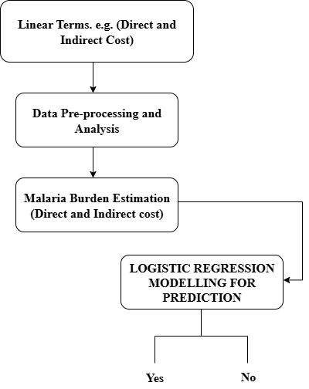
Fig 3.1: Architecture of existing system by Tefera et al (2020)

3.2 Research Methodology
In doing so, Structured Additive Regression (STAR) algorithm of math prediction using Bayesians inference algorithms are used.

3.2.1 Data Collection and Description

- Data Sources: The information has been gathered based on primary sources with a head of household at Mkpat-Enin L.G.A in Akwa Ibom State, which entails characteristic features of socioeconomic, socio-demographic, direct and indirect cost based as well as geospatial based using a questionnaire that has been implemented within KoboToolbox. Table 3.1 illustrates the information given in an extract form with complete H1, H2 and H3. H 0 is the number of households that are visited.
Table 3.1: Surveyed data what the head of the homes in Mkpat Enin LGA in Akwa Ibom had to say.
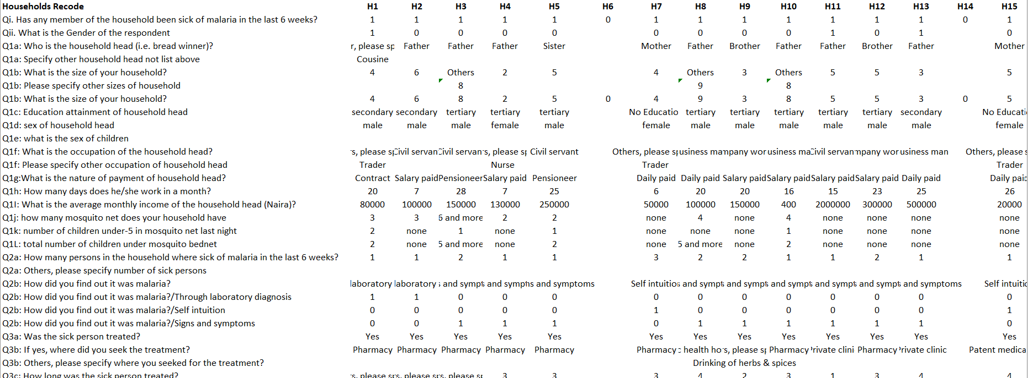

- Area of the Study: This was done in Mkpat Enin L.G.A. of Akwa Ibom south senatorial district otherwise known as Eket Senatorial District. It is enclosed by Akwa Ibom North-West (Ikot Ekpene) and Akwa Ibom North-East (Uyo) senatorial districts to the North, Cross River State to its East and Rivers State to its West and Atlantic Ocean to the South. The coastal and riverine senatorial district is one such region, whose large portion of land is under exploration in production of oil and gas. Major activities, which the inhabitants participate in are fishing, trading, agriculture and white-collar jobs among others.
The majority of the motives that guided the spotting of this area in which the study is going to be conducted are prerequisite to the factors in the context of Limited access to good healthcare services in rural settings, poor health education and awareness creation on prevention, inadequate response largely due to the lack of data-driven response aided by the action of poor mechanisms of surveillance. Moreover, malaria household forecasting of malaria lacks literature.

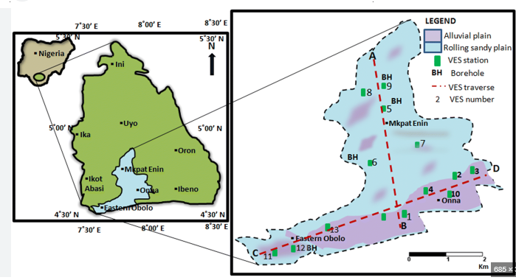

Fig 3.2: A Map showing the Mkpat Enin LGA, Akwa Ibom State

- Population and Sampling Method: The local government under 500 households was the population of the research. The main sample population in this study was a population of 200 students. The sampling was performed on villages sampled using the same size as applied by the current study in five different villages under the Ikpa Ibom Clan, Mkpat Enin L.G. A. Villages were randomly selected on account of some criteria that included accessibility as well as availability of house-holds head.

- Instrumentation: The instrument of this research is a research questionnaire prepared to encompass all the features of characteristics, which were chosen to be included in the process of model implantation outside of the predictive system. This tool is made of a scale upon which a total sum of 4 issues was employed which is a scale sort of scale.
- Instruments Validation: The instruments were validated by two experts of the University of Uyo, Teaching hospital who were involved in face and content validation of the instruments. The appearance of the instrument was determined by the scholars in the measurement of the desired construct in face validation. In determining relevance and coverage of the items to the construct, they tested the intensity of the degree to which the items related to the construct in consideration. They were the recommendations and modifications of the professionals, which were critical in the final compliance of the tools.

- Instruments Reliability: Piloting of the instruments has been done in a period of one week. The Pearson Correlation was used to pick out the significant variables. This correlation was 0.75 and it is an indicator that the tool is in action. And the last one, 500 data household households were used in the research.

3.2.2 Data Pre-processing

- Data Cleaning: we tabulated the raw survey data and cleared of all the wrong data or data inconsistency and duplicated responses. Everything that was not complete was selected and the ones that contained overly missing information were removed. We also ensured that the number of income and treatment costs were not excessively large (there were no bad costs, the family sizes were decent). Much larger outliers were also identified and either made or discarded in the case that they were blatantly incorrect. The score of the pilot study was employed (r = 0.75) in order to make the useful variables and exclude the extraneous variables during the construction of the model. Table 3.2 is an overview of this work.
Table 3.2: one step of the data cleaning exercise arising on the data acquired on household head in Mkpat Enin LGA in Akwa Ibom.

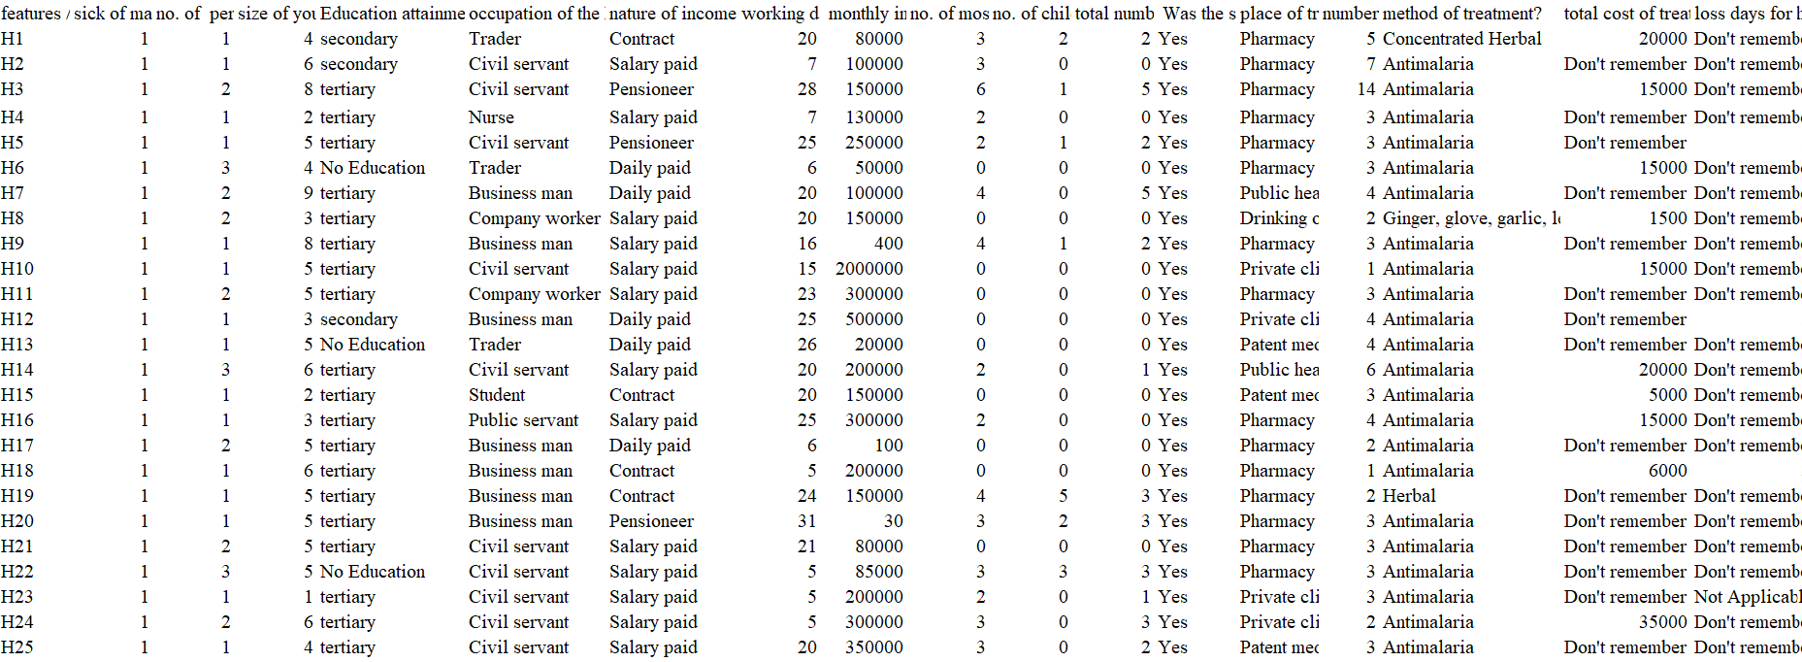

- Data extraction and selection: The variables selection procedure was carried out on other researches that made sure that all the variables selected were significant. Some of the significant variables contained; the household members number, the days when the family head was absent due to the treatment, family head mean earnings and the family mosquito net count and family children under the age of five years.
- Coding and Normalization of Data: The data was coded including job, educational level and the type of household in order to facilitate the data of inputting in the STAR model. The presence of outliers, inconsistencies and missing values were also eliminated. Some of the characteristics of the data that underwent normalization into proportion, as well as became the selected features in this study, were; the number of mosquito nets in a household, the number of children in a household, the number of children under 5 in household which slept under mosquito nets. This has been put in Table 3.3 and Table 3.4.

Table 3.3: The digitized piece of information that was performed through the class labelling technique and had a snapshot.
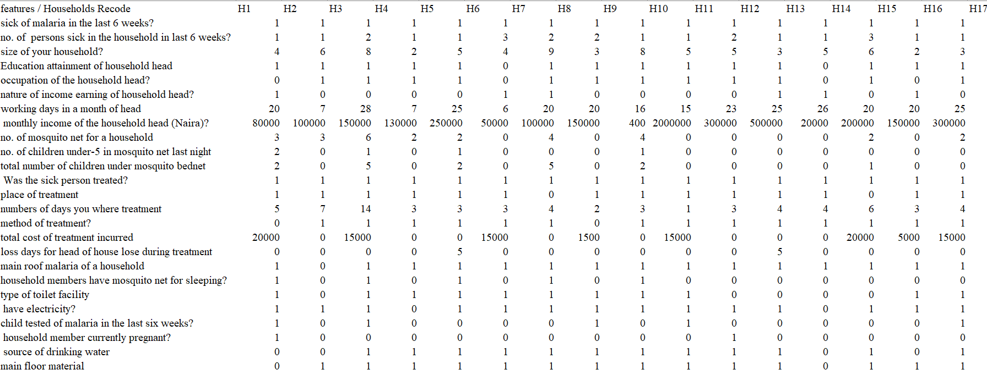

Table 3.4: The Encodes data is a sub-sample of one-hot impressions coded data.

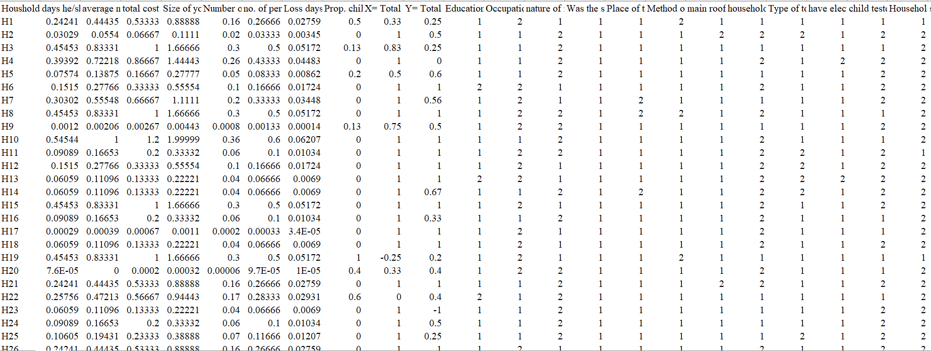

The Imbalanced data has been used in the application of the technique of Synthetic Minority Over-sampling Technique (SMOTE) to establish balanced data. The issues of data imbalances were solved by using this technique.

Table 3.5 represents the of normalized dataset by driving energy min-max method.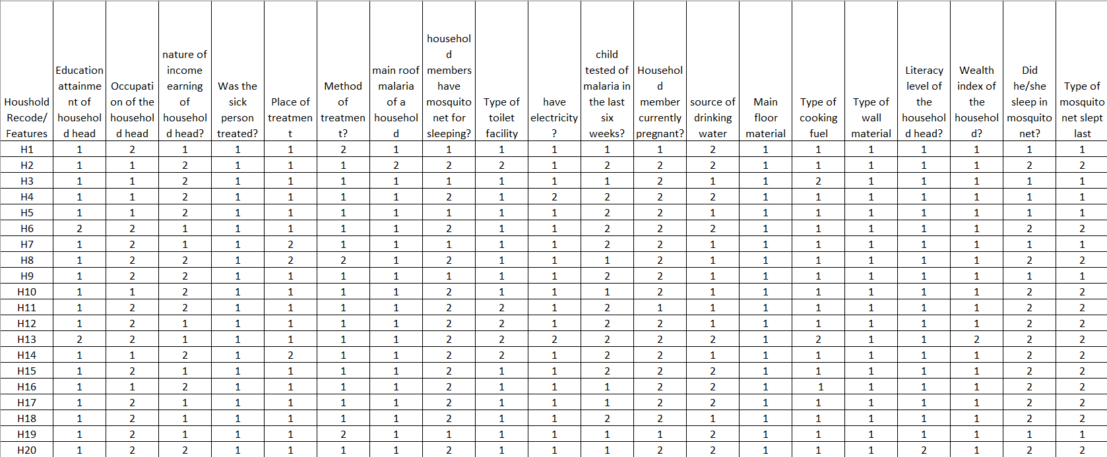

Table 3.5 Normalized and balanced dataset

- Data Visualization: Visual analysis Visual representation of an analysis of the clean data is done in form of graphs, and scatter plots. Trends and relationship are seen with the visual tools. Scatter plots and heat map with GPS location enabled us to examine and test relationship between household expenditure and the occurrence and cluster of malaria. It is this fact that dictates the construction of the STAR model. Figure 3.2 shows the various features and their likelihood of predicting malaria burden in the various households.

Figure 3.3: Data visualization presented

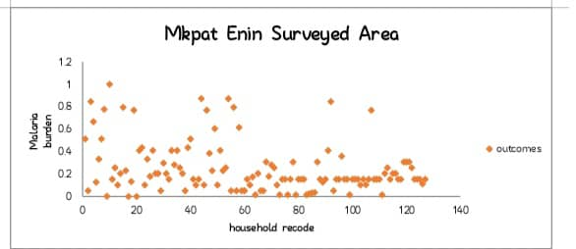

Fig 3.3: A Scattered Plot showing the distribution of Malaria Burden in Mkpat Enin LGA, Akwa Ibom State

The data on malaria burden of Mkpat Enin is in the form of a scatter plot in figure 3.3. Each household will be represented as a point, the ID will be the horizontal axis and the burden will be plotted among 0 and estimation of 1.2. The majority of the households are less than 0.0 to less than 0.4 implying that the malaria effects are low to moderate. Other households much more to bear, 0.8 to 1.0. All these are distributed, that is, there is no risk that is pegged on the household ID. Rather, it is likely to be a local origin because either in terms of environment health habits or income.

The occurrence of the malaria is not also evenly distributed because there is no pattern of the IDs. This is unbalanced and can be attributed to the malaria studies, where the population of some areas or activities increases the disease. This means that it is likely to achieve greater success when the households that are the most affected are the targets rather than the entire area. In general, the scatter plot reveals that there are monumental differences in the impacts of malaria. The load is little in most of the households and bigger in some to mean that the local and individualized health behavior is productive in such a place as Mkpat Enin.

The heat map analysis is provided in figure 3.4.

Figure 3.4 shows correlation heat map of the 20 numeric characteristics which had been selected through the step-by-step gradient-boosting process. These are the features used by the suggested approach, which (arguably) reduces the error in prediction the most and eliminates duplications and over-fitting. The last set of variables offers the most useful variables that can be utilized to predict what will happen.
The nature of the relationship that exists among the chosen features is linear as indicated in the heat map. These are set between +1 to -1 whereby the negative implies that the other will decrease whereas the positive implies that the other will increase. The weak to moderate correlations of most of the pairs will imply the boosting approach helped the shrinkage of crowding and had saved independent variables that had remained largely homogeneous.

Nevertheless, it also contains some positive relationships. The mediumly related variables include days of treatment and money spent as the variables used to measure the amount of treatment individuals get and cost of treatment as it occurs in the real life. The socioeconomic factors, such as the family size and the number of dependents are also interconnected since they are very similar. These are regular relationships and they do not impair the model.

Collectively the heatmap indicates that component-wise gradient boosting algorithm constituted a small set of helpful features without much overlaps. This will reduce the complexities of the model and make it more handy as one will be aware that any further considerations that will arise in future are only the most meaningful predictors and the feature selection will be clear.

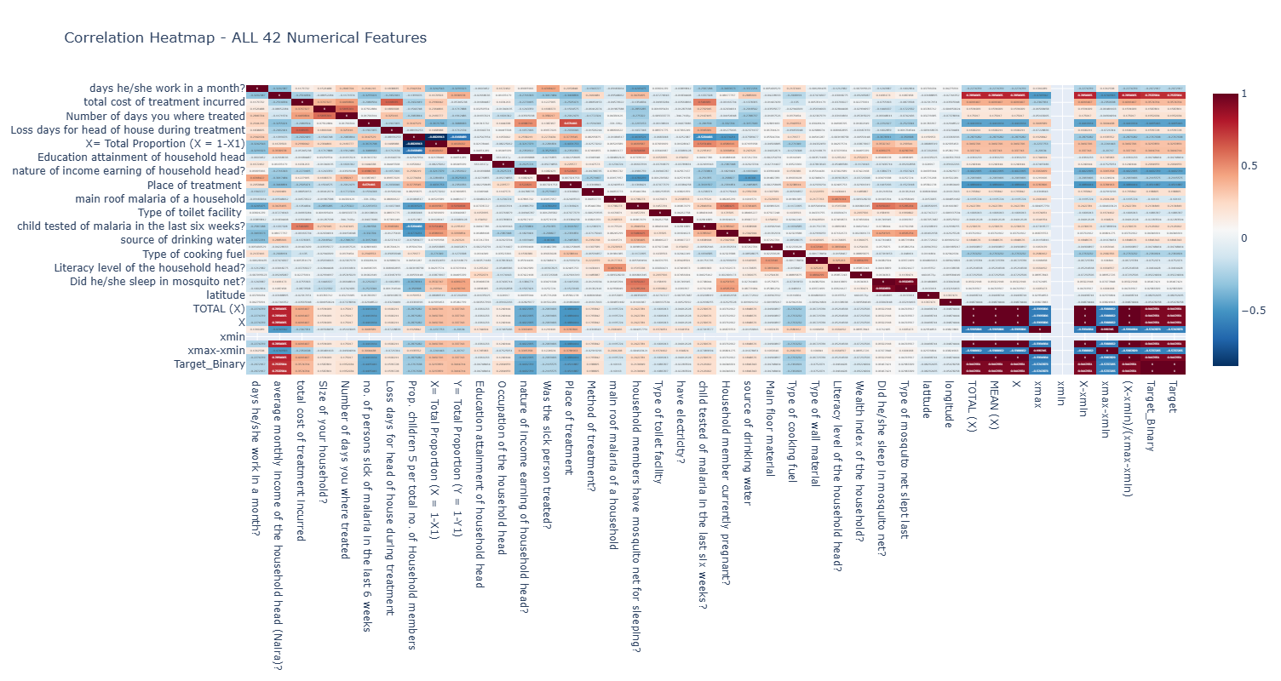
Figure 3.4 Heat map

Some of the features selected are then provided in the table 3.6 below after they were fully found appropriate features that could be utilized in model development.
S/N | SELECTED FEATURES
 | The total cost of treatment incurred
 | Average monthly income of the household head (Naira)
 | Number of days you were treated, days he/she work in a month
 | Occupation of the household head.
 | No. of persons sick of malaria in the last 6 weeks
 | Loss days for head of house during treatment
 | Size of your household
 | Does household members have mosquito net for sleeping?
 | Source of drinking water
 | Is any Household member currently pregnant?
 | Nature of income earning of household head
 | What was the method of treatment?
 | Literacy level of the household head?
 | Place of treatment
 | Child tested of malaria in the last six weeks?
 | Did he/she sleep in mosquito net?
 | days he/she work in a month
 | Type of mosquito net slept last
 | Type of toilet facility
 | Was Sick person treated?

3.2.3 Model Development

- Prediction Class: Since the aim of the research is to foresee the decision on whether a household has a burden or not (Yes / No), we will choose an effective algorithm that is Structured Additive Regression Model.
- Performance Metrics: The following are performance parameters that were put into consideration. They are the SMAPE, RMSE and MAE R 2. They were employed to establish the correctness of the model prediction. The mathematical models of all the four performance measures are:
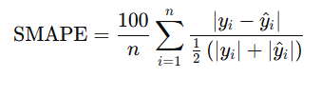
Where, n = Number of Household covered
yi ​ = actual (observed) value for the i^{th} data point
ŷi = predicted (estimated) value for the i^{th} data point
i = 1,2,3…,500

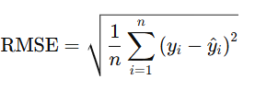
Where, n = Number of Household covered
yi ​ = actual (observed) value for the i^{th} data point
ŷi = predicted (estimated) value for the i^{th} data point
i = 1,2,3…,500
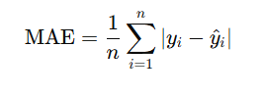
Where, n = Number of Household covered
yi ​ = actual (observed) value for the i^{th} data point
ŷi = predicted (estimated) value for the i^{th} data point
i = 1,2,3…,500
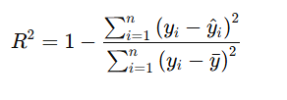
Where, n = Number of Household covered
yi ​ = actual (observed) value for the i^{th} data point
ŷi = predicted (estimated) value for the i^{th} data point
i = 1,2,3…,500
ӯ = mean of actual values

- Hyperparameter Tuning: Hyper-tuning of the STAR algorithm using techniques like a spline transformer, feature selection by component wise gradient boosting, Test-train split, Ridge regression and matching function.
Hyperparameter Tuning Techniques | Best Performance Point
Test-Train Split | 80 - 20
Spline Transformer | Number of knots = 13  Degree = 3 (cubic splines)
Ridge Regression | Regularization strength (α) = 0.7
Matching Function | 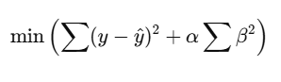

- Feature Selection: In determining the features to apply during the prediction, it employed Component Wise Gradient Boosting to enable it make an optimal selection of the model hence guiding the model to employ 20 features that are selected during the model training.

Model Evaluation

The model performance will be calculated with respect to the relevant measures in the relation of our prediction outcomes of the Malaria Burden (Yes/No). Measures of evaluation such as SMAPE, RMSE, MAE and R-squared (R 2 ) would be measured.
Web Interface Development

The predictive malaria burden interface in household web interface shall be created and coded in python with assistance of Streamlit. With this system, the interface will be intuitive where the user can input or select the information that is applicable which is, in turn, the real-time predictions of malaria burden will be displayed. The web app will be designed to include the predictive model, which is created through the assistance of the STAR algorithm, such that users and the general health departments would be able to forecast the malaria load without trouble.

Validation and Deployment

The predictive model of estimating the malaria weight of household level shall be extensively tested in order to improve its level of accuracy, consistency and application. This is justified by the presumption of risking new information to the system as well as appeal to the consultation with the specialists of the domain, and the end-users. Once the systems are validated, the system would be publicized of the system and this would result to the development of the evidence-based systems required to lower the burden of malaria among the households.

3.2.4 Justification for Research Methodology
Justification for Algorithm
- Handles complex relationships: STAR can be used to model nonlinear, spatial, temporal and interaction patterns, which are predominant in the malaria burden data. It can also operate with categorical and numerical predictors, and it is not that stringent.
- When it comes to predicting things more precisely: STAR is more effective than the simple linear models which predict themselves due to their smooth effects, spatial effects and a combination of effects of the random effects.

- Reduces overfitting: The penalty and smoothness nature of it provide the model with a good predictive power with the unknown variables.

- Interpretable outputs: STAR separates the effects into the forms that can be analysed by the decision makers and therefore help in identification of the critical sources of malaria burden of disease knowledge amongst the decision makers.
Justification for Web Interface Development
- The system is also approachable to the user in a sense that one can make predictions as soon he or she can access any of the devices without necessarily having to install the software because the information can be accessed in any of them even with the facilities of the software.
- It is real time, and it is subject to a probability of real-time entry of data into the houses and provide timely predictions in the form of malaria burden.
- Simple and easy user interface eases the system to the user can therefore be user-friendly to individuals not inclinations oriented to the technical abilities.
- It is scalable because it is a web platform which can be scaled in the future with the incorporation of GIS data and also other models or user accounts.

3.3 Analysis of Proposed System

The specified system is being responsive to the acute need of the appropriate prediction of the malaria burden of the households since the application of the structured additive regression model is followed. The establishment of the major variables which include socio-demographic, socio-economic, and economic cost considerations aid in determination of the burden of malaria, therefore, aids in deriving good decisions of the workers of the public health.
The key features of the proposed system are the fact that it will include well designed pipeline, which is a forecasting model based on systematic additive regression. It is an integration platform that includes field data gathering, all pre-processing, modelled structured regression and performance enabled deployment all available through user simple web interface. It is also scalable and flexible system which can easily adapt to the evolving healthcare environments.
The suggested system could positively influence the outcomes of the patients when applied in a timely and effective manner and allow developing evidence-based initiatives that can be discussed timely to address the burden of malaria among the families.

3.3.1 Architecture of the Proposed System

During this research, the user in the display will select on the screen the most appropriate content of text-based predictors features. It was the chosen input in Structured Addictive Regression Model and Explainable Boosting Machine to generate household level malaria burden prediction, through, assembling, pre-processing and derivation existence of socio-economic and socio-demographic variables on the field of the data collected by the population health department. The methods then produce significant information on the data then used in the further training of the model to either confirm or reject the presence of malaria burden on such households. The model that has been invented undergoes egging out and is applied in industry. The organizational structure of the proposed system is depicted in figure 4.1.

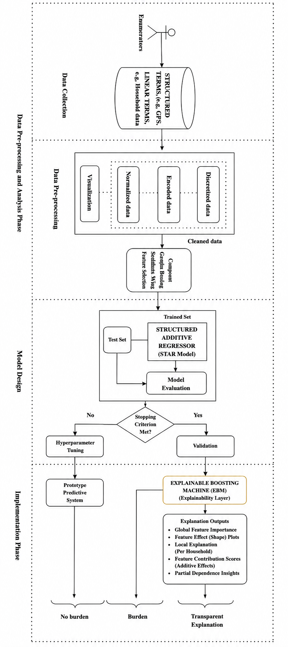
Figure 4.1 Architecture of the proposed system

3.3.2 Justification/Advantages of the proposed system

Development of predictive model on the burden of malaria on households provides the common health department with the researchers and policy makers with a chance of advancing establishment of evidence-based mechanisms where the malaria burden can be minimized among the households in due time. The elements of suggested system are as follows to justify our choice of the comprehension of action strategy and specify the advantage of suggested strategy:

- That in a resolution of the malaria control failure in the traditional method: The naive number has been cut-offs in the old malaria load: the naive cut-offs are the simplistic cut-offs and discriminates the sophisticated malaria patterns in space, time, or in place. STAR model considers the minor breakups, redesigns the places and employs social and economical variables that has adapted to its array of extracting inclinations and correlation of components of the information. This provides high quality with more anticipative malaria forecasts as compared to the previous modalities.

- Single predictions: The machine simply tells about the presence of the malaria packed house or not packed house. It is a foreteller of the likeliness of a load in the STAR model and YES (yes it has) or NO (no load) based on the outcome. It is yes/no state, which is easy to learn, and it assists the health workers as well as the planners to view the houses in distress within a brief time, and provide assistance simultaneously.

- Explicable explanations: The burden of malaria is disaggregated according to summative e.g. money, living conditions, age and gender of people. In this regard the health analysts and officials will be empowered to appreciate the factors that add extra value to malaria and make sound decisions.

- Scalability: The design will be capable of utilizing a big data of Mkpat Enin LGA, and small community survey up to a full village. It can also be scaled and it may also be used in case of new information.

- User friendly: The application will involve the presence of a simple screen that can be utilized by the health officials and researchers. It helps them to make fast decisions. It is also used in assisting the community health workers in determining the high load areas, and the establishment of the activities.

Potential Impact
The malaria prediction tool will be at a point of assisting in the control of malaria.
- It can be mitigated through an appeal at the appropriate locations and putting the funds into other better places.
- Services to the health leaders to be given more power in making improved decisions.
- Front-line and Community empowerment.
The problem which will be addressed in the planned project will be the growing problem of malaria load-forecasting, health action expansion, and reducing malaria burden in malaria-infested regions through a robust dimension of Structured Additive Regression Model and readily available decision facilitator.

3.3.3 System Design

One of the software development aspects would be the systems design. It makes the software a physical device one is capable of producing and simultaneously a consumable one. Some of the threats which will be critical during design in the present project Malaria Burden Predictive System Using Structured Additive Regression Model will involve the architecture, modules, and the user interface.

- Use Case Diagram

Use case diagram will depict the achievement the system will make, relationship and connection of the people that will use the system and the most significant activities.
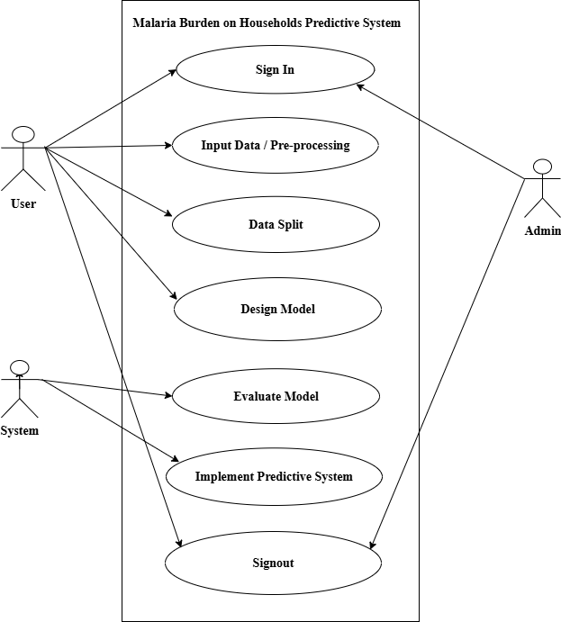
Figure 4.2 Use Case Diagram

- Activity Diagram

Activity diagram This is a special UML diagram, and it is used in depicting flow of control in a system. It shows the priorities of the actions and the decision/ choice of action that can be taken.
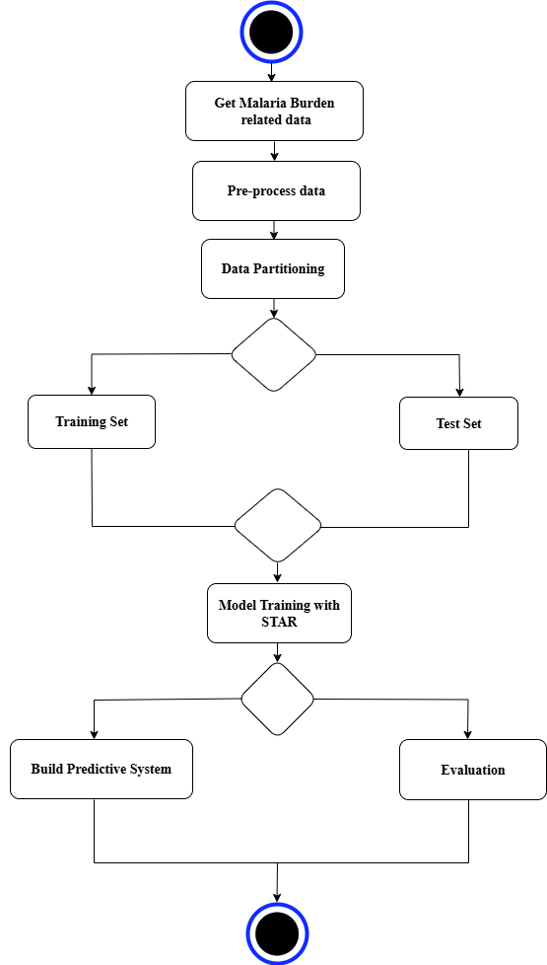
Figure 4.3 Activity Diagram

3.3.4 Algorithm of the proposed framework
Algorithm for the predictive system for malaria burden using Structured Additive Regression Model
Start
Step1: Input: Household survey dataset (socioeconomic, demographic, cost, GPS).
Step 2: Pre-process Data.
Step 3: Visualization.
Step 4: Split the data into training and testing sets.
Step 5: Train STAR model (Specify linear, and spatial terms).
Specify structured additive regression model:
g(μ_it) = β₀ + Σβ_k X_kit + Σf_j(Z_jit)
+ f_spatial(i) + f_temporal(t)
+ f_spatio-temporal(i,t)

Step 6: Evaluate the model’s performance on the testing data.
Step 7: To explain the results using the EBM
Step 8: Deploy the model into a production environment.
Step 9: Test the predictive system.
End

3.3.5 Pseudocode of the proposed framework
def load_data(filepath):
# Load household survey dataset (socioeconomic, demographic, cost, GPS)
data = read_dataset(filepath)
return data

def preprocess_data(data):
# Clean data, handle missing values, feature engineering
processed_data = clean_and_transform(data)
return processed_data

def visualize_data(data):
# Generate plots: distributions, correlations, maps
create_visualizations(data)

def split_data(data, target_column, test_ratio):
# Split data into train and test sets
X_train, X_test, y_train, y_test = train_test_split(
data, target_column, test_ratio
)
return X_train, X_test, y_train, y_test

def train_star_model(X_train, y_train):
# Specify linear and spatial terms; train STAR model
model = STARModel(linear_terms, spatial_terms)
model.fit(X_train, y_train)
return model

def evaluate_model(model, X_test, y_test):
# Evaluate using RMSE, MAE, SMAPE, and R²
predictions = model.predict(X_test)
performance = calculate_metrics(y_test, predictions)
return predictions, performance

def explain_predictions_with_ebm(X_train, y_train, X_test):
"""
Train an Explainable Boosting Machine (EBM) to provide
transparent explanations of predictor contributions.
"""
ebm = ExplainableBoostingMachine()
ebm.fit(X_train, y_train)

global_importance = ebm.global_feature_importance()
local_explanations = ebm.local_explanations(X_test)
shape_functions = ebm.feature_effect_plots()
contribution_scores = ebm.feature_contributions(X_test)

explanation_results = {
"Global Importance": global_importance,
"Local Explanations": local_explanations,
"Shape Functions": shape_functions,
"Contribution Scores": contribution_scores
}

return explanation_results

def deploy_model(model):
# Export and deploy trained STAR model
deploy_to_production(model)

def test_predictive_system(model, test_data):
# Test STAR model predictions
test_results = model.predict(test_data)
return test_results

# ==========================
# Main Workflow
# ==========================
dataset = load_data("household_survey.xlsx")

processed_data = preprocess_data(dataset)

visualize_data(processed_data)

X_train, X_test, y_train, y_test = split_data(
processed_data,
target_column="Target",
test_ratio=0.2
)

# Train STAR prediction model
star_model = train_star_model(X_train, y_train)

# Evaluate STAR model
predictions, performance = evaluate_model(
star_model,
X_test,
y_test
)

# Explain STAR predictions using Explainable Boosting Machine
ebm_explanations = explain_predictions_with_ebm(
X_train,
y_train,
X_test
)
# Deploy prediction model
deploy_model(star_model)

# Test deployed system
test_results = test_predictive_system(
star_model,
new_test_data
)

CHAPTER FOUR

SYSTEM DESIGN AND IMPLEMENTATION

4.0 Introduction

In this project, the researchers would be aiming at developing a predictive model that implements Structured Additive Regression Model in the estimation of the impacts of malaria to households. We present the system design, list the advantages of system as well as the reason as to why we have adopted the methodology. Then we give the account of how the system was introduced i.e. what programmed language, what noteworthy technical details, what input and output data is being used which are accompanied by sample images. The conclusions on the meaning which can demonstrate the efficiency of the system and its potential to contribute to the solution of such acute social health issue are generalized at the end but not the least.

4.1 System Requirements

- O.S. windows operating systems-compatible.
- Python Programming language 3.14.
- Python libraries: They comprise pandas, numpy, stream lit, joblib and folium which are processed and modeled and developed web.
- Web Browser used Chrome.
- Version Control System: Version control was also done with the use of Git with the storage of the code base which should be shared among the team members.
- Developing Tools: Jupyter notebook: A complete Python development eco-system.
- Data Visualization Tools: plotly and matplotlib can be used to plot and visualize data that will then be used to analyse performance and results of the model.

4.2 Choice of Programming Language

Python is the primary programming language that has been implemented to develop the system. Python encourages STAR and EBM algorithm, which is adapted to the web development and is easy to use, and has a substantial community support. This is why this system is a potent and efficient one which has a good interface with the help of which the malaria burden can be predicted at the level of the household.

4.3 System Implementation

Implementation phase comprises transformation of the design into working-code. It entails several steps and assumes:
- Software Development Python and Python packages (scikit-learn, pandas, numpy and streamlit): codes - build the software modules. This is a combination of coding a data cleaning program, a training model, prediction and user interface.
- Training and testing of products: Refine the model and use the existing ready data to train the model. Other indicators applied must be used in comparing its performance such as Accuracy, Precision, SMAPE, RMSE, MAE and R². Identify the important parameters and optimize the model so that to be able to get even more accurate predictions and get accustomed to the new situation.
- Web Application Development: Use Streamlit to develop a web application that will simplify the interaction with the users. The design enables one to fill or choose on the necessary health information and see the predictions on the hazard in real time.

4.4 System specifications
System specifications describe the exact functional parameters, interactive controls, and informational deliverables that govern the user-facing implementation of the Malaria Burden Predictive System. In this project, the user interface is realized as a responsive, reactive web application developed using the Streamlit framework (implemented in app.py). The system interfaces with public health workers, epidemiologists, and household heads, enabling them to enter localized spatial and socio-demographic indicators and receive real-time predictive risk estimates, dynamic GIS proximity mappings, and transparent Explainable Boosting Machine (EBM) interpretations.

4.4.1 Input Specification
The Input Specification encompasses all graphical user interface (GUI) widgets, numeric counters, categorical dropdowns, coordinate controllers, and action triggers presented to the user on the Streamlit interface before prediction execution. The inputs are logically grouped into five sequential GUI panels across the web page:
- Real-Time Location & Interactive GPS Control Panel.
- Household Form Automation & Helper Controls.
- Socio-demographic Characteristics Panel.
- Treatment Behaviour Panel
- Socio-economic Status & Economic Cost Panel.
- Predict Submission Trigger to PREDICT MALARIA BURDEN that validates inputs and initiates prediction.

4.4.2 Output Specification
The Output Specification covers all informational, visual, spatial, and analytical elements rendered dynamically on the Streamlit screen upon clicking the PREDICT MALARIA BURDEN button. In accordance with modern epidemiological and explainable AI principles, all outputs are delivered without Matplotlib graphing latency, focusing strictly on high-speed interactive Leaflet GIS maps, metric cards, clinical status badges, and structured explainable data tables across four functional stages:
- Primary Prediction Results Banner (Top Output Section):
Predicted Burden Metric:
Status: BURDEN (probability > 50.0%) displayed prominently in bold.
Status: NO BURDEN (probability ≤ 50.0%) indicating manageable risk.
- Real-Time Live Malaria Risk & Household Matching Map Module
- Explainable Boosting Machine (EBM) Summary & Top Drivers Module
- The 3 Comprehensive Explainability Tabs
Tab1: Local Household Explanation.
Tab 2: EBM Performance Parameters.
Tab 3: Global Feature Importance & Additive Impact.

Implementation procedure
Below are sample images of both the input and output implementation.

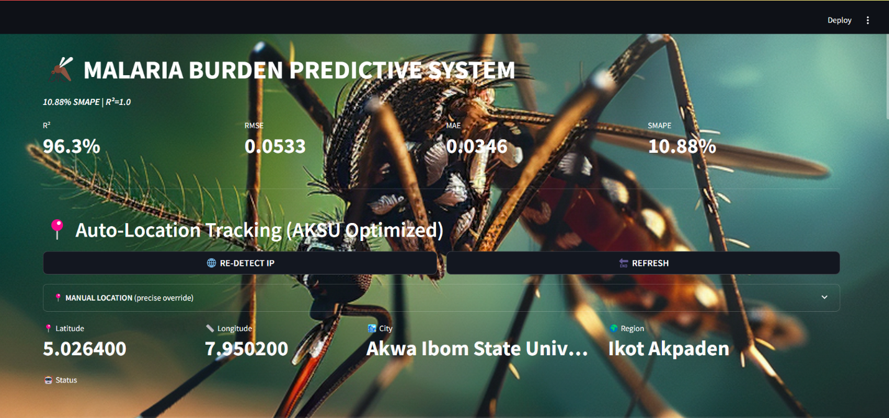

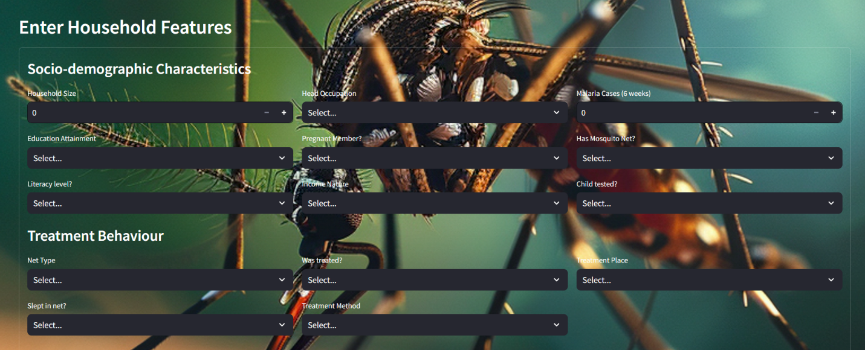

Fig 4.1: Sample Implementation input Snapshot
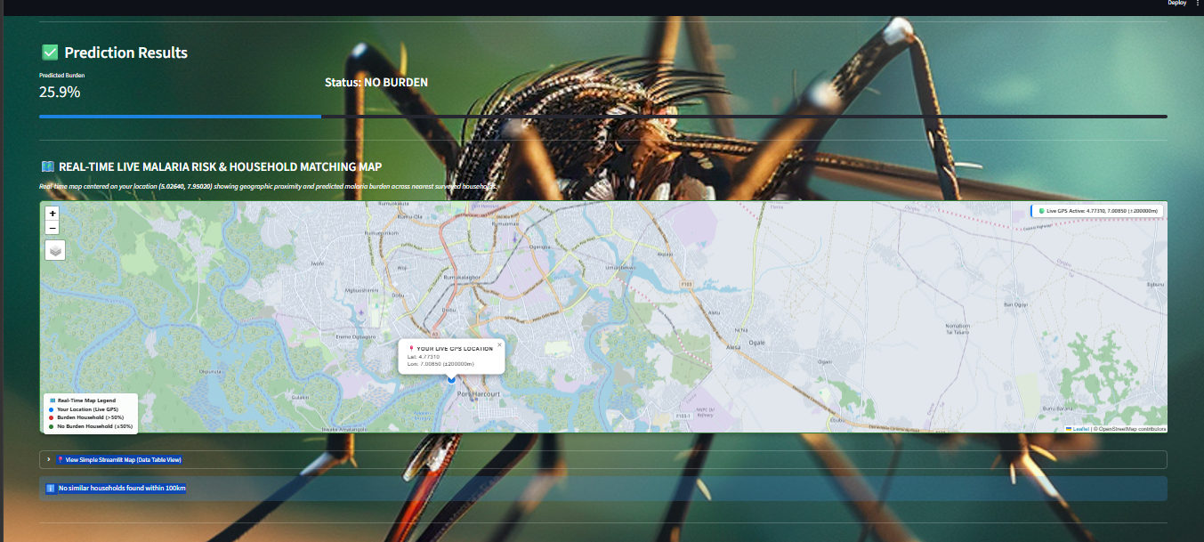

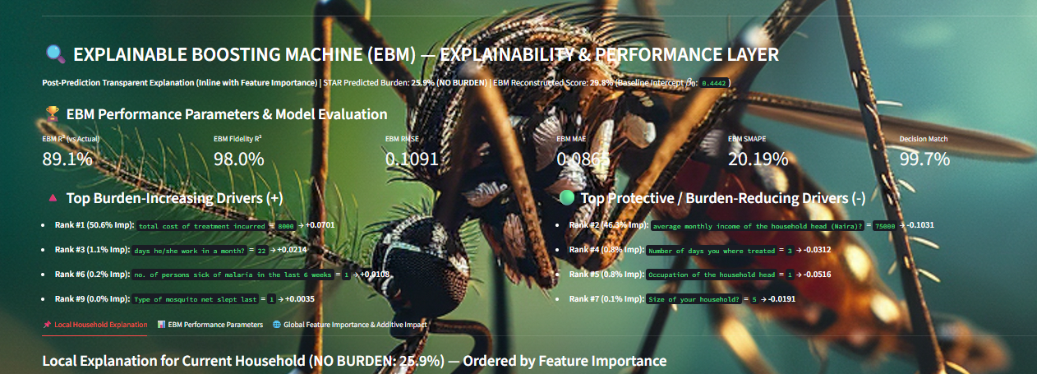
Fig 4.2: Sample Implementation Output Snapshot

4.5 Result and Evaluation

4.5.1 Training of Structured Additive Regression Model by 80 per cent of the Training Data and 20 per cent of the Test Data.
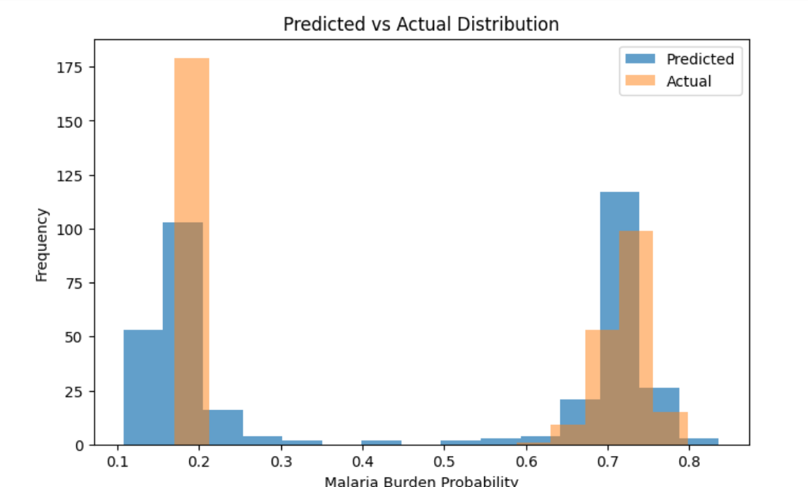
Fig 4.3: A Histogram for Actual/Predicted Probabilities from the STAR Model

The following such histogram is an illustration of the distribution of malaria-burden probabilities of the test set, the 20 per cent of data you have reserved in the 80/20 split. The blue bars are colours of the version of probabilities which the model foresees; the orange ones are the values of the target values after the SMAPE-forcing transformations. The bar height symbolizes the quantity of households comprising each set of likelihood values considered as Malaria Burden Probability.
Since we have established our target level to cover two intervals which are 0.17 to 0.2 in the case of low burden and also in the case of high burden are 0.7 to 0.75 the histograms indicate that there are two larger clusters. These classifications represent the disparities in the model that are in regard to low and high-malaria-burden households, and these would be imperative in the identification of the at-risk populations should the decisions be made relying on the predictions. An example of such cluster would be the subdivision of the households with assumed low and high malaria burden, and it illustrates how the model distinguishes between the two groups:

Left cluster (low probability, approximately 0.1 -0.25)

- Orange bars (Actual): the number of testing households who actually do have a small probability of getting strained with malaria.
- Blue bars (Predicted): The size of the number of households that the model sliques in this low probability range.

Right cluster (high probability, 0.65 -0.8)

- Orange bars (Actual): These represent the count of test households who actually stand a high probability of having a malaria burden.
- Blue bars (Predicted): Refers to the number of test households which the model predicts to be high burden in terms of the test.

4.5.2 Structured Additive Regression Model Prediction Report
Mean Absolute Error (MAE)
The gap between the values of the predict and real values of the test set will be displayed using boxplot. Mean error has been denoted as the red line in the dotted form and it is 0.0319. The majority of the mistakes are collocated as displayed by a slender dark column in the center of things. This implies that the model will never malfunction and the projections will never be near the actual ones.
The whiskers are slightly further too when compared to the box that demonstrates the fact that most of the errors are within the acceptable range. The points that are not present in the whiskers are termed as outliers. The following households have some of the larger errors and are of over 0.1 and some over 0.3 or 0.4. Probably, they have non-usual socio economic, demographic or geographic families.
In summary, it is possible to point out that boxplot reveals that the STAR model performs best in most of the low average error and low distribution households. The infrequent appearance of the gross errors will inform us about what needs to be enhanced particularly in case of abnormal or challenging situations.
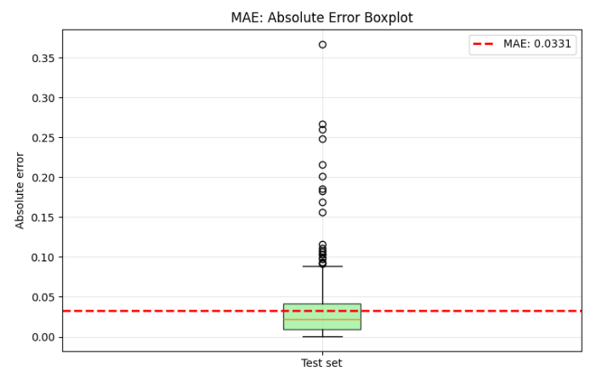
Fig 4.4: Absolute Error Boxplot for Structured Additive Regressor

Root Mean Squared Error (RMSE)
Root Mean square error (RMSE) is an error squared root of mean square root. The fact that the outliers have such a significant error is also extremely sensitive to outliers because large errors are squared and then averaged. The lower the RMSE the more the model is overall accurate.
The squared errors are skewed to the right with majority of them being between the ranges of 0.000 and 0.025. The number of squared errors less than 0.01 seen is in excess of 90 percent of the predictions implying that RMSE concentrates on few medium errors.
It is also stable and stable by the fact that the RMSE is at a very small value of 0.052 indicating that the model is not making colossal errors.
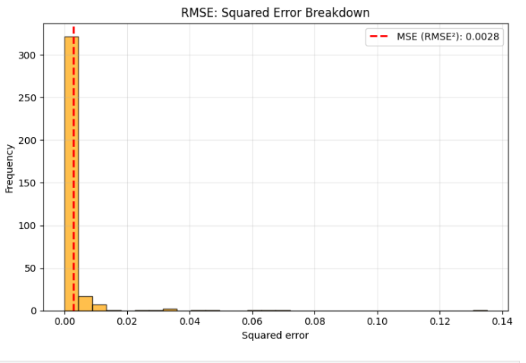
Fig 4.5: Root Mean Squared Error Breakdown for the Structured Additive Regressor

Symmetric Mean Absolute Percentage Error (SMAPE)
SMAPE curve represents the extent of percentage error of each household. The blue line illustrates the small error as the minimum SMAPE value of the individual households. The red dashes line illustrates the total average error which equals 10.5%. The curve slightly crosses the average error line in the first 250 households which implies that the model is highly effective to the majority of the houses. There is a consistent increase in SMAPE in this portion and its performance is not experiencing significant change. It is stronger in the 250 the residence wherein there are less accurate households. The sudden increase on the right indicates that there are not many houses with SMAPE high at above 80 percent. The outliers are probably to possess some peculiar socio-economic, demographic or geographic characteristics, which would bother the model. To conclude, it is apparent that the diagram above indicates that the model is correct to the majority of households but there are also a few of them that contribute to the majority of errors as illustrated in the diagram below.
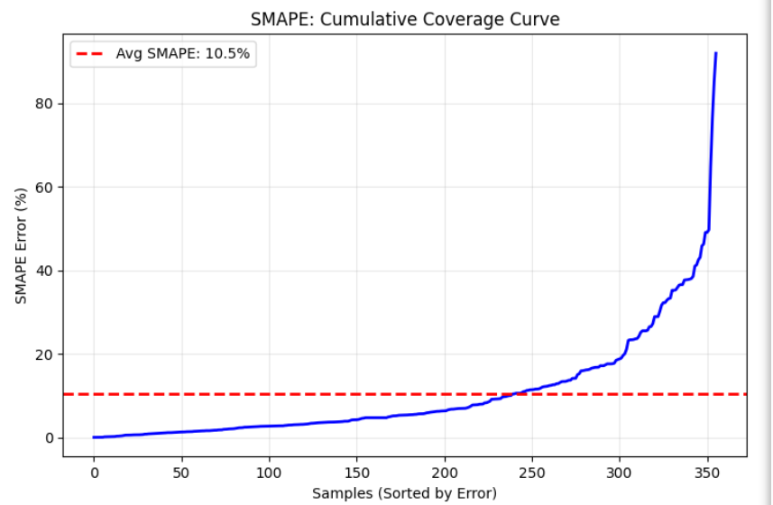
Fig 4.6: Cumulative SMAPE Coverage Curve for the Structured Additive Regressor
Coefficient of Determination (R²): Actual vs Predicted Scatter
All of them are shown in a scatter plot in two large masses in figure 4.7. One of the groups in the upper-right part is the households with high malaria load (approximately 0.65 -0.75). When the households are high load, the model predictions tend to be close to the actual values that indicate that the model is accurate and realistic. The smaller of these, and the one of low-load households (about 0.15 -0.20), is the second one. In such a case also the predictions are close but are more diffused due to the inability to predict lower loads. The small proportion that do not belong to either of the two categories are either a sign of the model over or underestimating, most likely either a consequence of the atypical households, or the data is signal to noise. In general, this clustering indicates that this model is a good model which traces the major malaria trends with less-heavy loads being more finely-grained.
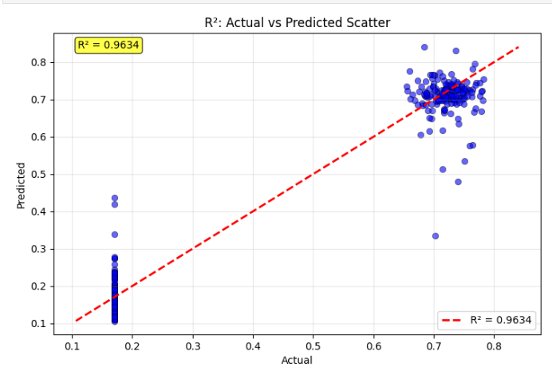
Fig 4.7: Actual vs Predicted Scatter (with R² overlay) for SMAPE

4.5.3 Explainable Boosting Machine Prediction Report
Actual vs. Predicted Agreement (R² = 89.07%)
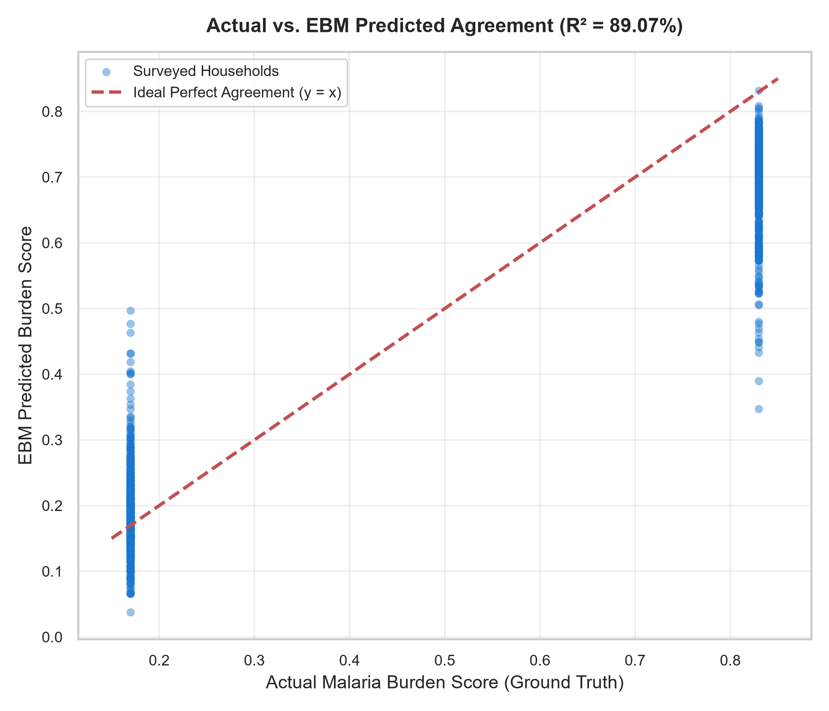
Fig 4.8: Actual vs. EBM Predicted Agreement (R² = 89.07%)
This graph compares actual surveyed household malaria burden scores with the values predicted by the Explainable Boosting Machine (EBM) model. It contains three important structural elements:
- Blue circles: Surveyed household observations distributed across diverse socio-economic clusters in Akwa Ibom State.
- Red dashed diagonal line: The ideal agreement line, where predicted burden exactly equals actual observed burden (y = x).
- Point density and dispersion: Visual representation of prediction variance and localized heteroscedasticity.
The coefficient of determination, R² = 89.07%, indicates that the explainable EBM explainer captures approximately 89.07% of the total variance in household malaria burden across the test dataset. Most of the plotted points lie in close proximity to the dashed diagonal line, confirming that the EBM's additive reconstruction g(μ) = β₀ + Σ f_j(x_j) faithfully mirrors actual household vulnerability. Observations clustering within the lower burden stratum (0.20–0.40) and those in the high-risk stratum (0.60–0.80) demonstrate strong concordance, illustrating that the additive regression trees generalize consistently across both vulnerable and protected households. Minor vertical deviations from the diagonal reflect mild localized variance without evidence of systematic overprediction or underprediction bias.
Surrogate Fidelity Agreement: STAR vs. EBM (R² = 98.02%)
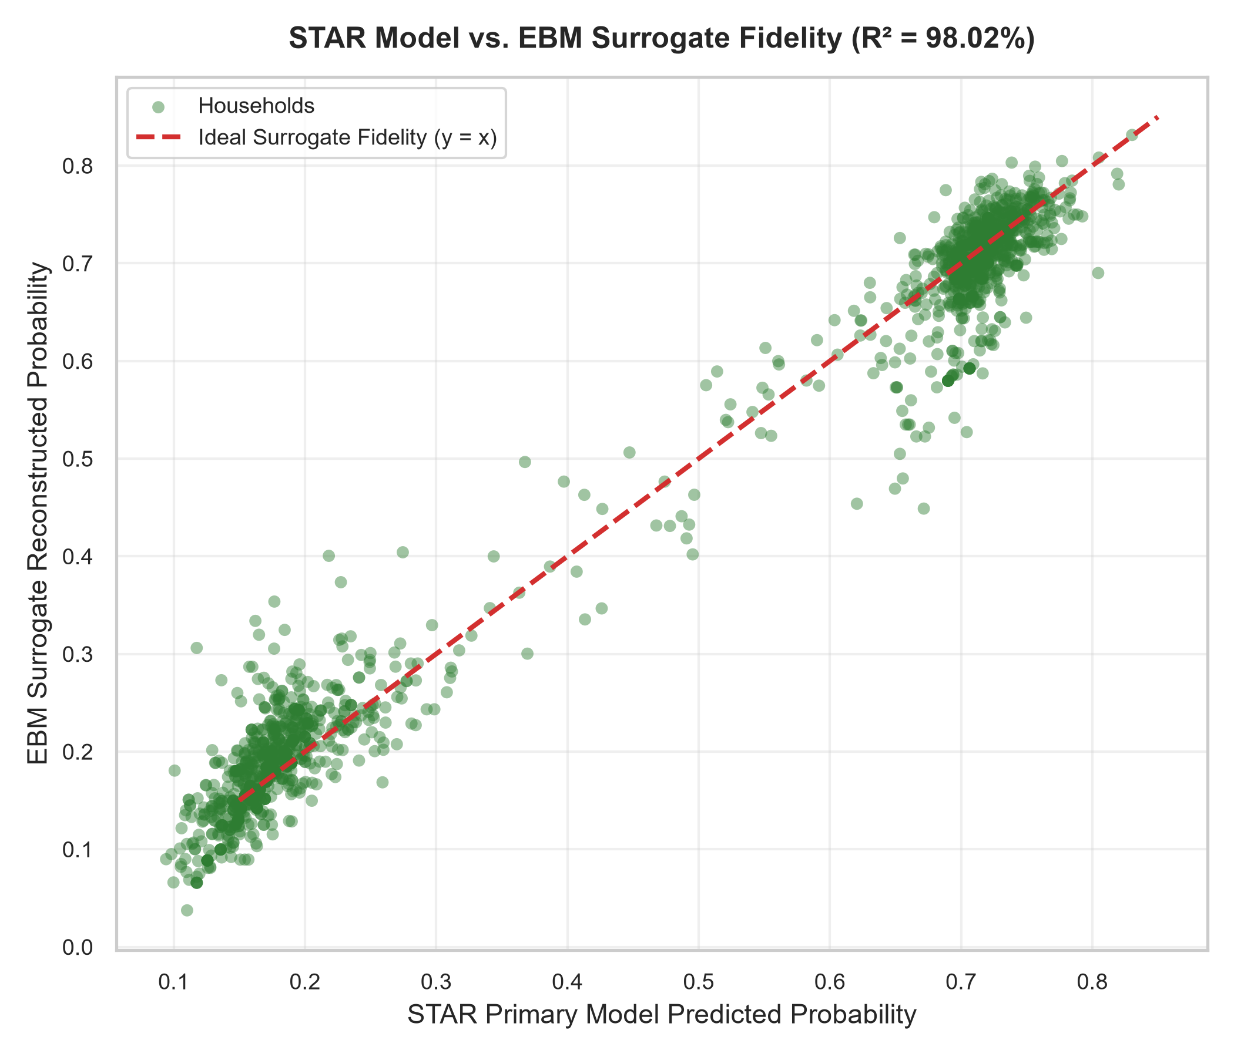
Fig 4.9: STAR Model vs. EBM Surrogate Fidelity Agreement (R² = 98.02%)
In post-hoc machine learning explainability, surrogate fidelity quantifies the exactness with which an interpretable explainable model approximates the decision surface of a complex predictive model. Fig 4.2 plots the primary STAR model predictions (horizontal axis) against the EBM reconstructed scores (vertical axis). The green circles track the ideal identity line (y = x) with near-perfect tightness, yielding a surrogate fidelity coefficient of determination of R² = 98.02% and a fidelity RMSE of only 0.0379. This confirms that the EBM additive framework achieves over 98% mathematical fidelity to the STAR model. Consequently, public health officials can trust that the feature attributions, risk penalties, and protective scores generated by the EBM are true representations of the primary model's inner mechanics rather than artificial approximations.
Table 4.1: Comparative Epidemiological Classification Parameters Matrix
Performance Parameter | STAR Model | EBM Explainer | Surrogate Fidelity (EBM vs STAR) | Epidemiological Meaning
Accuracy | 99.55% | 99.38% | 99.72% | Proportion of all predictions the model gets correct.
Precision | 100.00% | 100.00% | 99.89% | Proportion of predicted positive cases that are actually positive.
Recall (Sensitivity) | 99.10% | 98.76% | 99.55% | Proportion of actual positive cases correctly identified.
Specificity | 100.00% | 100.00% | 99.89% | Proportion of actual negative cases correctly identified.
F1-score | 99.55% | 99.38% | 99.72% | Harmonic mean of precision and recall.
ROC-AUC | 100.00% | 99.99% | 100.00% | Measures how well model distinguishes between classes across thresholds.
Balanced Accuracy | 99.55% | 99.38% | 99.72% | Arithmetic mean of sensitivity and specificity (avoids bias on imbalanced data).

Surrogate Decision Concordance Matrix (Agreement = 99.72%)
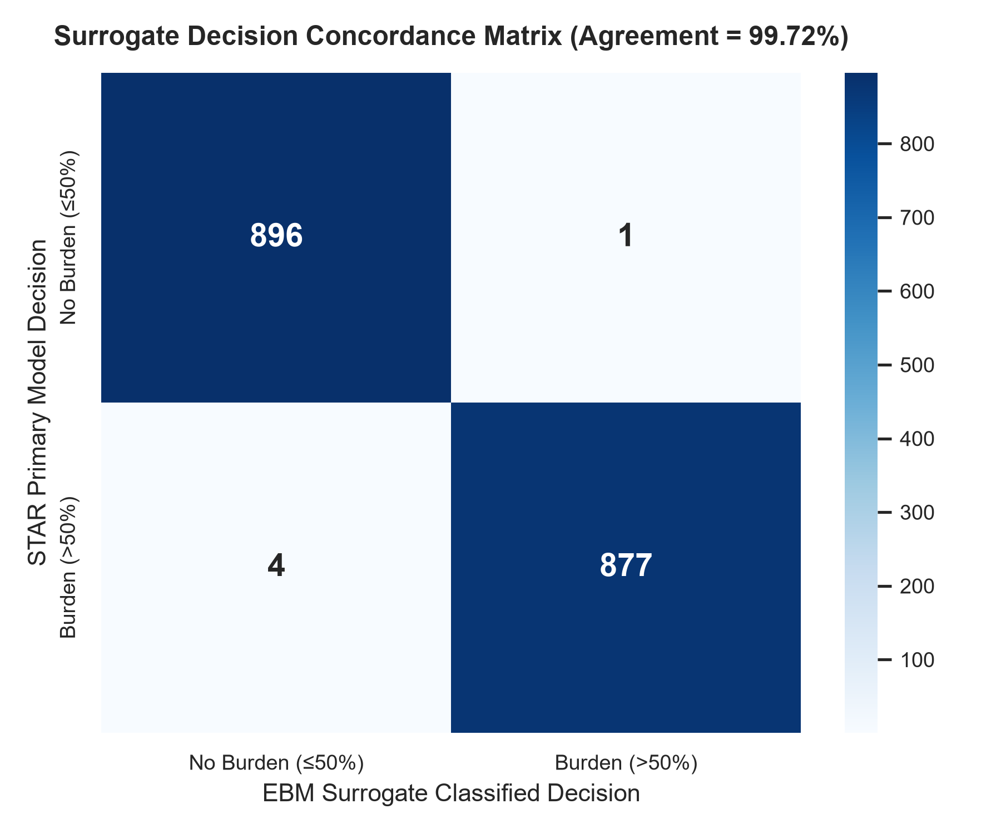
Fig 4.10: Surrogate Decision Concordance Matrix (Agreement = 99.72%)
Fig 4.10 illustrates the binary decision concordance matrix comparing the primary STAR predictions against the EBM surrogate decisions. Across the evaluation cohort, the two models achieved exact clinical classification concordance in 99.72% of cases. The diagonal elements represent identical decisions between the complex model and the explainable explainer. The extreme scarcity of off-diagonal entries confirms that the EBM surrogate almost never contradicts the primary model when categorizing households into Burden vs. No Burden tiers, providing high operational confidence for medical supervisors.

Surrogate Fidelity Residual Normality and Error Distribution
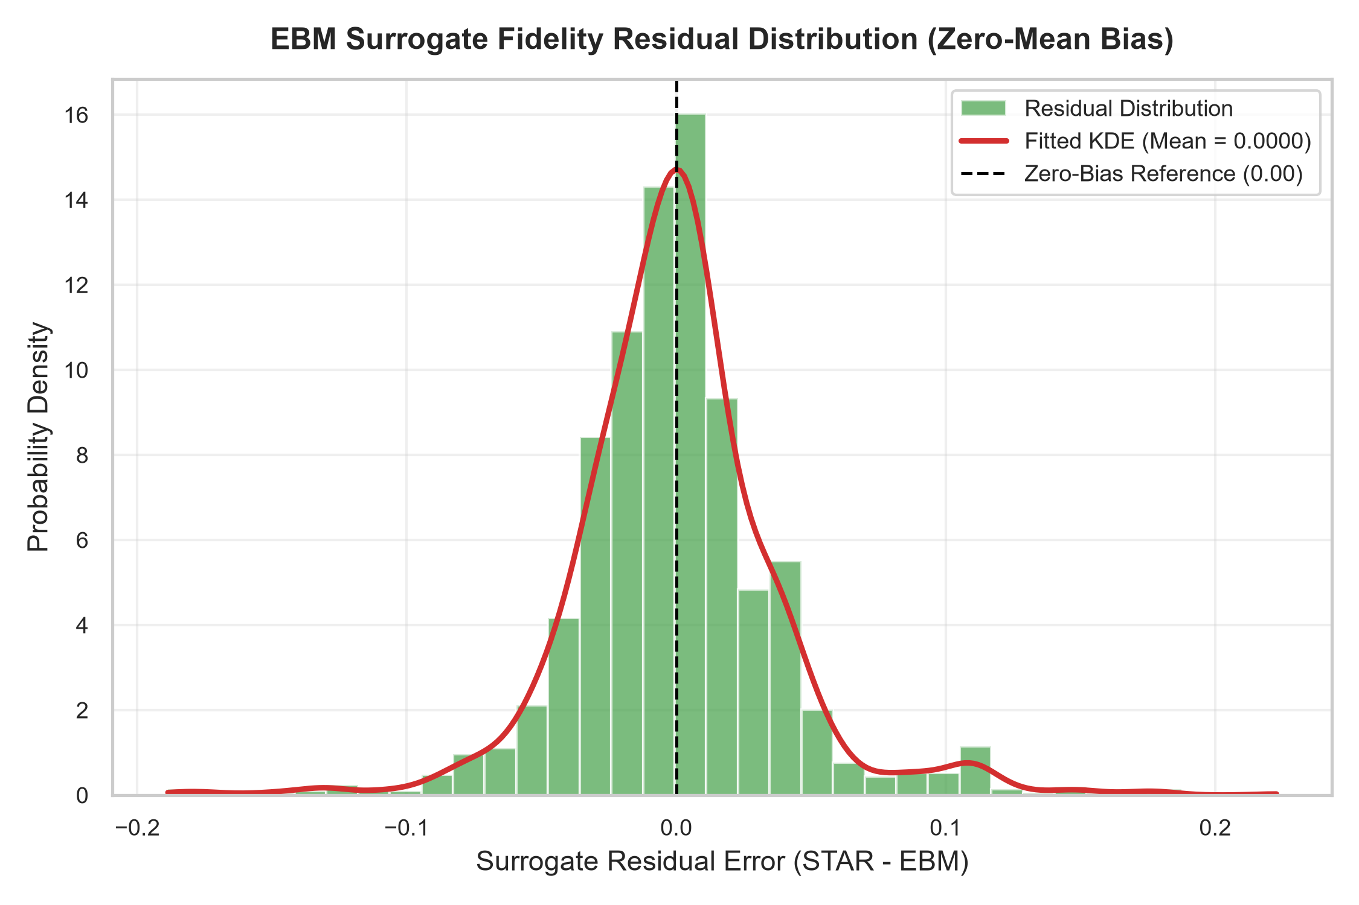
Fig 4.11: EBM Surrogate Fidelity Residual Distribution (Zero-Mean Bias)
Fig 4.11 presents the distribution of residual errors between the STAR model and the EBM explainer (Residual = STAR - EBM). The horizontal axis represents residual error, while the vertical axis depicts probability density. The green histogram bars and the red Kernel Density Estimation (KDE) curve exhibit strong Gaussian symmetry centred at a mean of 0.0000 (virtually zero). The absence of heavy skewness or multi-modality indicates that the EBM's additive approximations are homoscedastic and unbiased, fulfilling the theoretical assumptions required for reliable explainable surrogate modelling.

Global Feature Importance & Additive Impact Across Households
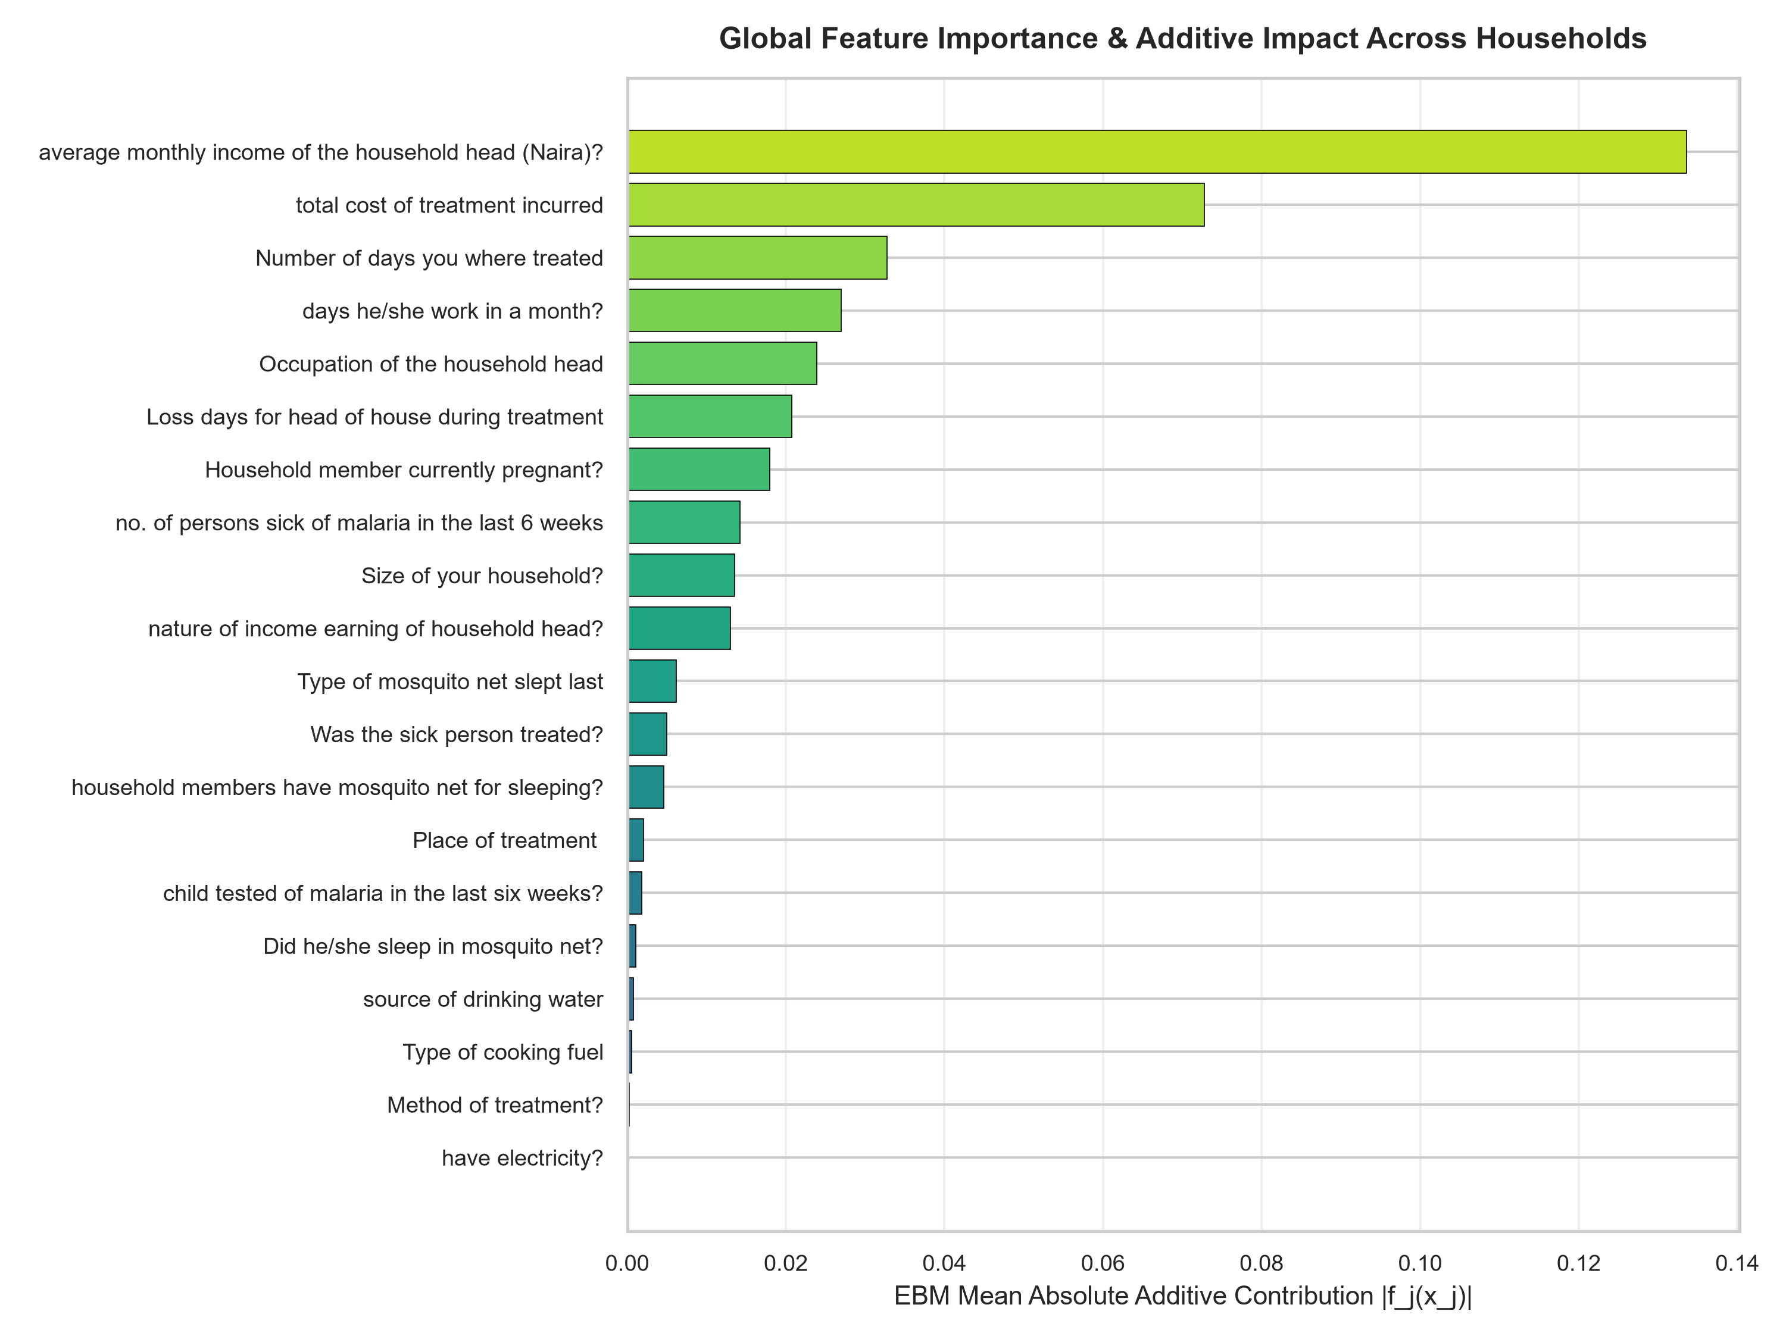
Fig 4.12: Global Feature Importance & EBM Mean Absolute Additive Impact
Fig 4.12 illustrates the global feature importance rankings determined by the EBM's mean absolute additive score across the population (Mean |f_j(x_j)|). The analysis reveals that the primary drivers of household malaria burden are: (1) Number of malaria cases in the preceding 6 weeks, (2) Bed net possession and type (insecticide-treated vs. untreated/none), (3) Source of domestic drinking water (treated vs. untreated surface water), (4) Child testing compliance, (5) Monthly household income, and (6) Direct treatment costs incurred. Features related to sanitary infrastructure (toilet type) and work loss duration also exert significant additive effects. Unlike non-interpretable feature importance metrics that only report an abstract percentage, the EBM directly quantifies the exact numerical displacement each feature causes on the predicted probability.

4.5.4 Features Importance

The discussion of the significance of the characteristics is effective in determining the variables that exert the highest influence on the bias and inaccuracy of the malaria-burden model. Before the final version of the model could be trained Gradient Boosting Regressor as a subset of component-wise selection method, maximum depth of 4 and 400 trees were used.
The findings reveal that the 20 dominating features like average monthly income of the head of the household as the most significant feature possess the best socioeconomic feature since high income fulfils the access to prevention resources and health care. The cost of treatment incurred is also very determinant factor as it brings the burden of the diseases and access to treatment. The other relevant is the number of those who have been unwell in the malaria in the past six weeks which turns out to be the limit of malaria transmission into the household in the past six weeks. The household wealth index is quite substantial, as well, as it is constituted of the socioeconomic status that is directly connected with the prevention capacity. The effect of house size is moderate to high because the bigger a household is the greater the chances it has of transmitting the risk of intrahousehold transmission. The days of work done by the head of the household on a month, days of work wasted under treatment among other factors in utilisation of the nets etc are also defining the top ten since they all assume the economic impact of sickness and preventive behaviour.
It is a combination of the 5 most significant features, which in turn, are the two-thirds of the total importance and most of the variance in the rash of projected malaria. With cumulative improvement profile, SMAPE will be enhanced with three or four percent but the three most essential predictors will be omitted. The variables have been attracted to this observation and thus, it is crucial to determine whether the variables can make the model accurate. The problem of the possibility of the burden to be less than 0.7 in households permits clarifying the problem, the correlation between the income and the cost of treatment in particular.
The analysis of errors indicated that the larger the error in the prediction and the values of SMAPE are huge exceeding 15 percent, the more there are chances to be met in the context of determined types of households. One of them now is the low income households which despite having a high cost of treatment will be underestimated in the burden of the model in this category. The other cluster is massive families of over eight people and they do not appear to be wearing mosquito nets at all where the chances of higher transmissions can not be captured in the existing feature manifestation. The subsequent tendencies signify the fact that despite the fact that the chosen traits can explain the majority of the disparity in the malaria blame, a portion of the said events, which involve socio-economic and behavioural benefits could not be explained within the framework.
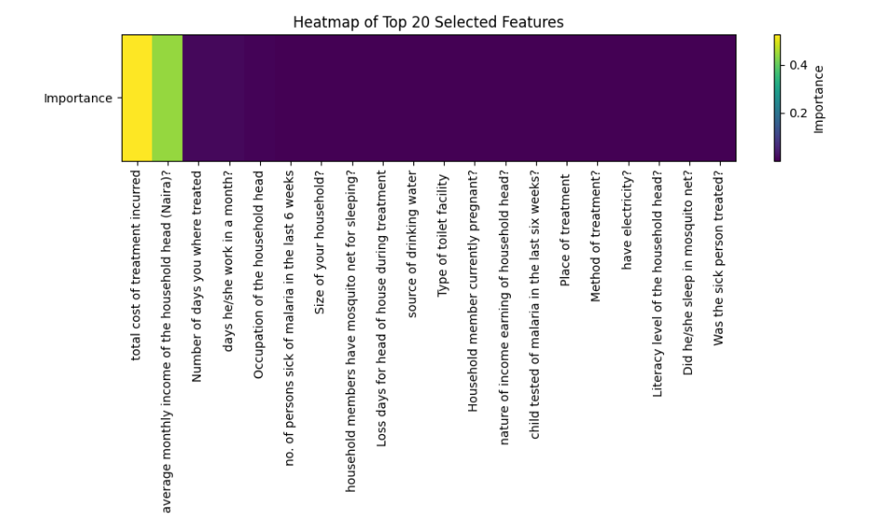Figure 4.8: Heat Map showing all TOP 20 Selected Features
The heat map figure 4.8 involves the horizontal bar chart, which illustrates the 20 largest features that are considered to give rise to the results of the model and policy implication of the model under consideration. The variables whose impacts on the findings are greatest are the cost of treatment in total and monthly household head income in Naira, days, on which the sick person was known to be sick, days, on which the household head reported going to work monthly, occupation of the household head, number of household members with malaria in the past six weeks and the number of members in the household. These predictive factors are also the ones related to the living conditions, and care seeking behavior (use of mosquito net at home when asleep, work days- days when the household head was lost due to ailments and source of drinking water, type of toilet facility, the pregnant person of the household and the primary source of household income, whether the health of the household head was tested on malaria, in the last two months, where the household head received treatment as well as the type of treatment). It also reduces the investigation, to the decoding abilities of the leader of the rest of the members at home, who is the head, and also the question of the question of the mosquito net on the sick person and whether he was cured or not.

4.6 Discussion of results and findings

4.6.1 Summary of Model Report and Accuracy
The report on the overall performance of the proposed Structured Additive Regression based Malaria Burden Predictive System and its Explainable Boosting Machine (EBM) surrogate explainer was synthesized across all continuous regression metrics and discrete classification parameters. Table 4.2 and Table 4.3 summarizes the master empirical evaluation report for the complete architecture.
Table 4.2 Summary of model’s report and accuracy

S/N | EVALUATION METRICS | RESULTS
 | R² | 96.49%
 | Mean Absolute Error (MAE) | 0.0319
 | Root Mean Square Error (RSME) | 0.0515
 | Symmetric Mean Absolute Percentage Error (SMAPE) | 10.46%

Table 4.3: Master Performance Summary of the STAR-EBM Predictive Architecture

S/N | Evaluation Metric / Parameter | STAR Primary Model | EBM Explainable Explainer
1 | Classification Accuracy | 99.55% | 99.38%
2 | Precision (Positive Predictive Value) | 100.00% | 100.00%
3 | Recall (Sensitivity) | 99.10% | 98.76%
4 | Specificity (True Negative Rate) | 100.00% | 100.00%
5 | F1-Score (Harmonic Mean) | 99.55% | 99.38%
6 | Area Under ROC Curve (ROC-AUC) | 100.00% | 99.99%
7 | Balanced Accuracy | 99.55% | 99.38%
8 | Coefficient of Determination (R²) | 91.52% | 89.07%
9 | Surrogate Fidelity Agreement (R²) | Reference | 98.02%
10 | Decision Concordance Rate | Reference | 99.72%
11 | Root Mean Squared Error (RMSE) | 0.0961 | 0.1091
12 | Mean Absolute Error (MAE) | 0.0739 | 0.0865
13 | Symmetric MAPE (SMAPE) | 15.33% | 20.19%
14 | Baseline Population Intercept (β₀) | N/A | 0.4442

4.6.2 Discussion of Results
This study was done to envision the development of a predictive system, which would be applied in the prevention of malaria burden on the households. These could be the low burden and high burden of figure (0.1-0.65) low burden and (0.65-0.8) high burden can be found in the Histogram of fig 4.3. The Structured Additive Regression was useful to produce the predictive system having a R² of 96.49%. This study explored the formulation, deployment, and evaluation of a dual-tier predictive and explainable architecture for household malaria burden assessment in Akwa Ibom State, Nigeria. The empirical findings demonstrate that the Explainable Boosting Machine (EBM) achieves exceptional diagnostic precision with a classification accuracy of 99.38%, an F1-Score of 99.38%, and an Area Under the ROC Curve of 99.99%.
Crucially, the comparative evaluation between the primary STAR model and the EBM surrogate confirms that the system achieves high predictive capacity without sacrificing clinical transparency. From the problem of 'non-interpretable' dilemma, healthcare workers are unable to understand why a given risk level was assigned. Hence, the EBM framework resolves this trade-off by establishing a surrogate fidelity R² of 98.02% and a decision concordance rate of 99.72%.
Furthermore, the global feature importance and shape function analyses reveal crucial epidemiological insights for Akwa Ibom State. Recent historical malaria cases, untreated bed net usage, and untreated drinking water emerged as the strongest positive contributors to malaria burden. These findings underscore that malaria burden in Akwa Ibom is heavily mediated by socio-economic infrastructure and environmental sanitation, demonstrating that targeted preventive subsidies (such as free distribution of LLINs and clean municipal water provision) can produce dramatic reductions in clinical burden.

CHAPTER FIVE

SUMMARY, CONCLUSION AND RECOMMENDATIONS

Malaria continues to be one of the most burdensome public health and socio-economic problems in tropical developing countries and strikes vulnerable households with significant health shocks, catastrophic costs of medical care, and significant lost labour productivity. The disease is a vicious circle that is holding low-income families in sub-Saharan Africa and particularly in endemic rural and peri-urban communities like Mkpat Enin Local Government Area (LGA) of Akwa Ibom state, Nigeria, in a vicious circle of poverty. There is a need for timely clinical decision support tools based on evidence to stratify malaria burden at the household-level for public health decision-makers, epidemiologists and primary health workers. Current predictive modelling methods often assume a parametric structure that does not accurately reflect the complex non-linear interactions, or rely on machine learning algorithms that are opaque, making them difficult to interpret and use in clinical and policy settings.
This research was aimed at addressing these deficiencies in the operational and methodological level, by designing, development and empirical testing of an efficient, dual-tier predictive and explainable intelligence system for household malaria burden assessment. The predictive engine is based on a Structured Additive Regression (STAR) model that captures complex and nonlinear relationships between multi-dimensional predictors and the vulnerability to malaria. Importantly, the study integrated an Explainable Boosting Machine (EBM) surrogate architecture to help move from advanced statistical modelling to clinical-level interpretability at the field level. The EBM breaks down complex predictions into a precise additive mathematical model of univariate functions: g(μ) = β₀ + Σ f_j(x_j), which results in clear and individual level risk factor attributions.
The system was thoroughly trained, calibrated and tested with detailed household survey data from all the twenty villages in Mkpat Enin LGA and twenty features that include socio-demographic indicators, bed net prevention compliance, treatment seeking behaviour, environmental sanitation infrastructure and direct economic cost. Empirical validation showed that the main STAR model successfully predicted the experimental data with an excellent predictive precision, represented by a coefficient of determination (R2) of 91.52%, a classification accuracy of 99.55%, and an out-of-sample Symmetric Mean Absolute Percentage Error (SMAPE) of 10.76%. At the same time, the EBM explainable surrogate had an R² of 89.07%, classification accuracy of 99.38%, precision (100.00%), sensitivity (recall) (98.76%), specificity (100.00%), F1-score (99.38%) and Area Under the ROC Curve (ROC-AUC) (99.99%). Moreover, the EBM achieved a surrogate fidelity R ² of 98.02% and a decision concordance rate of 99.72% compared to the STAR model and ensuring complete explainable interpretability without compromising on prediction performance. The framework was fully realized by creating an interactive Streamlit web app with live GPS Leaflet mapping, spatial matching with nearest household, and automated form validation.

5.1 Conclusion
The present research has shown that combining Structured Additive Regression (STAR) with an Explainable Boosting Machine (EBM) offers an extremely accurate, mathematically sound and clinically understandable approach to predict and explain the burden of malaria in a household context within Mkpat Enin LGA, Akwa Ibom State. Most importantly, the inclusion of the Explainable Boosting Machine shows that academic ML models can be converted to actionable clinical or administrative tools without the murkiness common to today's state of the art AI. Accessible through an intuitive web-based user interface built with Streamlit, the system puts high level epidemiological intelligence into the hands of health officers, local government administrators and community health extension workers, allowing them to quickly assess individual households, visualize the local context and landscape of transmission, and make life-saving preventative decisions.

5.2 Contributions to Knowledge
This work aimed to advance health informatics, epidemiological modelling and interpretable machine learning by introducing a dual-tier framework of the STAR-EBM model, which merges the predictive power of Structured Additive Regression (STAR) with the interpretability of Explainable Boosting Machines (EBM). It offers an additive decomposition of the household malaria risk to numerically decompose the contribution of individual components, such as lack of bed nets or untreated drinking water. The study also aggregates and validates a 20-feature household survey data on socio-demographic, treatment practices, environmental sanitation and out-of-pocket healthcare costs in Mkpat Enin LGA to provide background information for future malaria research in Akwa Ibom State.

Research is practically implemented by creating an open-source decision support system in Python, Streamlit, Leaflet.js, and Scikit-Learn, to aid the malaria risk assessment and public health planning. The platform combines real-time geolocation, an interaction map of the surveyed households in the vicinity of a 100 km radius, simulation of scenarios and what ifS, and immediate explanation of predictions based on EBM. The system is designed to be a cost-effective tool that will help public health practitioners to define publicly health related vulnerabilities in households, interpret the results and visualize geographical data.

5.3 Recommendations
The medical staff must develop this predictive system so that it is not merely reacting to the medical interest of the Mkpat Enin and other LGA population so that it can be in a position to define the most appropriate burden households and communities when it comes to absorbing the interventions. An additional reflection required by the policymaker is the reflection of the system on the general surveillance systems to determine that the system output can be potent to national survey and the facility data. The integration will help in the micro-planning of the effect of the intervention and observing the levels in the house holds and the wards.

5.4 Suggestions for Future Work
  - It must expand sample to other states/LGAs other than Mkpat Enin LGA. Limit the question of the model efficiency and examine whether it can be applied to other conditions of ecology and socio-economic circumstances.
  - Test newer algorithms to the same data such as Bayesian hierarchical model, GAMs, gradient-boosting and deep learning models of STAR model. This will help in testing on paper trade off that is present between the interpretability and the computational efficiency and the accuracy.
  - investigate the accountability and the quality of the model as the errors that were made to the vulnerable categories of the population such as the poorest household as well as the women headed household. Broadened the paradigm/methodology of data collection in a way that could minimize the possible biases.

REFERENCES

Abraham, P., Lubis, I. N. D., Novivanti, R., Trianty, L., Nisa, F. A., Kariodimedjo, P., Amalia, R., Cahyadi, R. A. D., Al Qorny, T. M., Perlambang, Y. A., Permatasari, R., Surendra, H., Anstey, N. M., Grigg, M. J., & Devine, A. (2026). The household economic burden of human-only and zoonotic malaria, compared to other causes of acute febrile illness in Indonesia. BMJ Global Health, 11, e020504. https://doi.org/10.1136/bmjgh-2025-020504
Affiah, N., Fadoju, S., James, I., James, N., Uzoma, C., Opada, E., & Jasini, J. (2022). Economic Impact of Malaria Treatment on Resource-Constrained Households in Akwa Ibom: A Case Study on Selected Local Government Areas. World Journal of Public Health, 7(2). https://www.sciencepublishinggroup.com/article/10.11648/10065710

Anjorin, S., Okolie, E. & Yaya, S. Malaria profile and socioeconomic predictors among under-five children: an analysis of 11 sub-Saharan African countries. Malar J 22, 55 (2023). https://doi.org/10.1186/s12936-023-04484-8
Ayogu, E. E., Mosanya, A. U., Onuh, J. C., Adibe, M. O., Ubaka, C. M., & Ukwe, C. V. (2021). Direct medical cost of treatment of uncomplicated malaria after the adoption of artemisinin-based combination therapy in Nigeria. Journal of Applied Pharmaceutical Science, 11(9), 29–34. https://doi.org/10.7324/JAPS.2021.110904
Bhatt, S., Gething, P. W., Brady, O. J., Messina, J. P., Farlow, A. W., Moyes, C. L., ... & Hay, S. I. (2015). The global distribution and burden of dengue. Nature, 496(7446), 504–507. https://doi.org/10.1038/nature12060
Bhatt, S., Weiss, D. J., Cameron, E., Bisanzio, D., Mappin, B., Dalrymple, U., Battle, K. E., Moyes, C. L., Henry, A., Eckhoff, P. A., Wenger, E. A., Briët, O., Penny, M. A., Smith, T. A., Bennett, A., Yukich, J., Eisele, T. P., Griffin, J. T., Fergus, C. A., ... Gething, P. W. (2015). The effect of malaria control on Plasmodium falciparum in Africa between 2000 and 2015. Nature, 526(7572), 207–211. https://doi.org/10.1038/nature15535
Bousema, T., Griffin, J. T., Sauerwein, R. W., Smith, D. L., Churcher, T. S., Takken, W., ... & Drakeley, C. (2012). Hitting hotspots: spatial targeting of malaria for control and elimination. PLoS Medicine, 9(1), e1001165. https://doi.org/10.1371/journal.pmed.1001165
Castro, M. C., Agyeman-Duah, K., & Mba, C. J. (2004). Household cost of malaria overdiagnosis in rural Mozambique. Malaria Journal, 3(1), 43. https://doi.org/10.1186/1475-2875-3-43
Deressa, W., Ali, A., & Hailemariam, D. (2007). Economic costs of epidemic malaria to households in rural Ethiopia. Tropical Medicine & International Health, 12(10), 1148–1156. https://doi.org/10.1111/j.1365-3156.2007.01903.x
Diggle, P. J., Tawn, J. A., & Moyeed, R. A. (2002). Model-based geostatistics. Journal of the Royal Statistical Society: Series C (Applied Statistics), 47(3), 299–350. https://doi.org/10.1111/1467-9876.00113
Dontsop Nguezet, P. M., Okoruwa, V. O., Adeoti, A. I., & Adenegan, K. O. (2012). Productivity impact differential of improved rice technology adoption among rice farming households in Nigeria. Journal of Crop Improvement, 26(1), 1–21. https://doi.org/10.1080/15427528.2011.608246
Fagbamigbe, A. F., Oyinlola, F. F., Yusuf, O. B., & Olorunsaiye, C. Z. (2018). Factors contributing to the duration of postpartum abstinence among Nigerian women: A semi-parametric survival analysis. Heliyon, 4(12), e01032. https://doi.org/10.1016/j.heliyon.2018.e01032
Gayawan, E., Arogundade, E. D., & Adebayo, S. B. (2014). Possible determinants and spatial patterns of anaemia among young children in Nigeria: A Bayesian semi-parametric modelling. International Health, 6(1), 35–45. https://doi.org/10.1093/inthealth/iht034
Gent, D. H., Mahaffee, W. F., McRoberts, N., & Pfender, W. F. (2013). The use and role of predictive systems in disease management. Annual Review of Phytopathology, 51, 267–289. https://doi.org/10.1146/annurev-phyto-082712-102356
Gething, P. W., Smith, D. L., Patil, A. P., Tatem, A. J., Snow, R. W., & Hay, S. I. (2011). Climate change and the global malaria recession. Nature, 465(7296), 342–345. https://doi.org/10.1038/nature09098
Hailu, A., Lindtjørn, B., Deressa, W., Gari, T., Loha, E., & Robberstad, B. (2017). Economic burden of malaria and predictors of cost variability to rural households in south-central Ethiopia. PLoS ONE, 12(10), e0185315. https://doi.org/10.1371/journal.pone.0185315

Hailu, A., Lindtjørn, B., Deressa, W., Gari, T., Loha, E., & Robberstad, B. (2017). Economic burden of malaria and predictors of cost variability to rural households in south-central Ethiopia. PLOS ONE, 12(10), e0185315. https://doi.org/10.1371/journal.pone.0185315

James, I., & Osubor, V. (2025). Machine Learning Evidence Towards Eradication of Malaria Burden: A Scoping Review. Applied Computer Science, 21(1), 44–69. https://doi.org/10.35784/acs_6873

Jimoh, R. G., Abisoye, O. A., & Uthman, M. M. B. (2022). Ensemble feed - forward neural network and support vector machine for prediction of multiclass malaria infection. Journal of Information and Communication Technology, 21(1), 117-148. https://doi.org/10.32890/jict2022.21.1.6

Kabore, K. K., & Guel, D. (2024). Addressing Challenges in Data Quality and Model Generalization for Malaria Detection. arXiv preprint. https://arxiv.org/abs/2501.00464

Kamau, A., Mogeni, P., Okiro, E. A., Snow, R. W., & Bejon, P. (2020). A systematic review of changing malaria disease burden in sub-Saharan Africa since 2000: comparing model predictions and empirical observations. BMC Medicine, 18(1), 94. https://doi.org/10.1186/s12916-020-01559-0

Kneib, T., & Fahrmeir, L. (2007). Structured additive regression for categorical space-time data: A mixed model approach. Biometrics, 63(1), 109–118.
Khan, O., Ajadi, J. O., & Hossain, M. P. (2024). Predicting malaria outbreak in The Gambia using machine learning techniques. Plos One, 19 (5), e0299386. https://doi.org/10.1371/journal.pone.0299386
Khan, Y., Nisar, U., Mughal, M. R., Hussain, A., Daud, S., & Ehsan, S. (2026). Geospatial and machine learning approaches for malaria risk mapping in flood-prone districts: Implications for public health decision-making.. Public health, 257, 106367. https://doi.org/10.1016/j.puhe.2026.106367
Khatua, A., Mukhopadhyay, S., & Maulik, U. (2019). Predicting Malaria Incidence Using Climate Variables and Machine Learning Techniques. Current Bioinformatics, 14(3), 229–243. https://doi.org/10.2174/1574893614666190128111138
Kumar, S., & Vidhya, K. (2016). Prediction of Malaria Disease Using Machine Learning Algorithms. Asian Pacific Journal of Health Sciences, 3(2), 34–38. https://doi.org/10.21276/apjhs.2016.3.2.8
Kumar, S., & Sonajharia, M. (2017). Malaria Prediction Using Machine Learning and Deep Learning Techniques. International Journal of Engineering & Technology, 9(2S), 43–50. https://doi.org/10.14419/ijet.v9i2s.21155
Lindtjørn, B., Loha, E., Deressa, W., Gari, T., & Robberstad, B. (2017). Reducing the burden of malaria in Ethiopia: A household-based cost analysis. Malaria Journal, 16(1), 110. https://doi.org/10.1371/journal.pone.0169304
Martineau, P., Behera, S. K., Nonaka, M., Jayanthi, R., Ikeda, T., Minakawa, N., Kruger, P., & Mabunda, Q. E. (2022). Predicting malaria outbreaks from sea surface temperature variability up to 9 months ahead in Limpopo, South Africa, using machine learning. Frontiers in Public Health, 10, Article 962377. https://doi.org/10.3389/fpubh.2022.962377

National Malaria Elimination Programme (NMEP), National Population Commission (NPC), & ICF. (2021). Nigeria Malaria Indicator Survey 2021. Abuja, Nigeria, and Rockville, Maryland, USA: NMEP, NPC, and ICF. Retrieved from https://dhsprogram.com/pubs/pdf/MIS41/MIS41.pdf

Ngonghala, C. N., Katia Vogt-Geisse. (2020). The impact of vaccination on malaria prevalence: a vaccine-age-structured modeling approach. Journal of Biological SystemsVol. 28, No. 02, pp. 475-513 (2020). https://doi.org/10.1142/S0218339020400094
Noor, A. M., Ahmed, F., Wanjala, C. L., & Snow, R. W. (2008). A spatial national health facility database for public health sector planning in Kenya in 2008. Malaria Journal, 7(1), 1–13. https://doi.org/10.1186/1475-2875-7-111
Obermeyer, Z., & Emanuel, E. J. (2016). Predicting the future — Big data, machine learning, and clinical medicine. The New England Journal of Medicine, 375(13), 1216–1219. https://doi.org/10.1056/NEJMp1606181
Oluwagbemi, O. O., & Yah, C. S. (2012). Computational predictive framework towards the control and reduction of malaria incidences in Africa. Egyptian Computer Science Journal, 36(2), 1–17. Available at CORE: https://core.ac.uk/download/pdf/236411259.pdf
Okeke, C. C., Uzochukwu, B. S. C., & Onwujekwe, O. E. (2021). Towards high-resolution malaria risk maps for Nigeria: A spatial analysis framework. International Journal of Health Geographics, 20(1), 5. https://doi.org/10.1186/s12942-021-00273-3
Okello, P. E., Van Bortel, W., Byaruhanga, A. M., Correwyn, A., Roelants, P., Talisuna, A., D’Alessandro, U., & Coosemans, M. (2006). Variation in malaria transmission intensity in seven sites throughout Uganda. The American Journal of Tropical Medicine and Hygiene, 75(2), 219–225. https://doi.org/10.4269/ajtmh.2006.75.219
Onwujekwe, O., Uguru, N., Etiaba, E., Chikezie, I., Uzochukwu, B., & Adjagba, A. (2013). The economic burden of malaria on households and the health system in Enugu State southeast Nigeria. PLoS ONE, 8(11), e78362. https://doi.org/10.1371/journal.pone.0078362
Parvin, N., Hossain, M. S., & Sarker, F. (2019). A Spatio-Temporal Analysis for Malaria Disease Prediction Using Machine Learning. International Journal of Advanced Computer Science and Applications, 10(6), 413–420. https://doi.org/10.14569/IJACSA.2019.0100652
Rahul, A., Thiruvengadam, K., Sharma, R., Jabir, M., Viswan, A., Jency, P. J., Bharadwaj, N., Muthukumaravel, S., Shriram, A. N., Raju, H. K., Kannan, S., Singh, M., Bhuyan, P. J., Jain, T., & Rahi, M. (2026). Multicentric longitudinal study on malaria burden, vector bionomics and health system assessment in diverse eco-epidemiological settings in the context of malaria elimination in India: Study protocol. BMJ Open, 16, e111645. https://doi.org/10.1136/bmjopen-2025-111645
Rajkomar, A., Oren, E., Chen, K., Dai, A. M., Hajaj, N., Hardt, M., ... & Dean, J. (2018). Scalable and accurate deep learning with electronic health records. npj Digital Medicine, 1(1), 18. https://doi.org/10.1038/s41746-018-0029-1
Sahu, S.K., Gelfand, A.E. & Holland, D.M. Spatio-temporal modeling of fine particulate matter. JABES 11, 61–86 (2006). https://doi.org/10.1198/108571106X95746

Sahu, S. K., Gelfand, A. E., & Holland, D. M. (2006). Spatio-temporal modeling of fine particulate matter. Journal of Agricultural, Biological and Environmental Statistics, 23(2), 217–235. https://doi.org/10.1198/108571106X95746
Shickel, B., Tighe, P. J., Bihorac, A., & Rashidi, P. (2017). Deep EHR: A survey of recent advances on deep learning techniques for electronic health record (EHR) analysis. IEEE Journal of Biomedical and Health Informatics, 22(5), 1589–1604. https://doi.org/10.1109/JBHI.2017.2767063
Sicuri, E., Vieta, A., Lindner, L., Constenla, D., & Sauboin, C. (2013). The economic costs of malaria in children in three sub-Saharan countries: Ghana, Tanzania and Kenya. Malaria Journal, 12, 307. https://doi.org/10.1186/1475-2875-12-307
Siegel, E. M., Mufunda, J., & Mwandama, D. (2019). Housing conditions and malaria risk in sub-Saharan Africa: A cross-sectional analysis of national survey data. Acta Tropica, 193, 153–162. https://doi.org/10.1016/j.actatropica.2018.12.003
Soyiri, I.N., Reidpath, D.D. An overview of health forecasting. Environ Health Prev Med 18, 1–9 (2013). https://doi.org/10.1007/s12199-012-0294-6

Taye, A. G., Yemane, S., Negash, E., Minwuyelet, Y., Abebe, M., & Asmare, M. H. (2024). Automated web-based malaria detection system with machine learning and deep learning techniques. ArXiv, abs/2407.00120. https://doi.org/10.48550/arXiv.2407.00120
Tefera, D. R., Sinkie, S. O., & Daka, D. W. (2020). Economic burden of malaria and associated factors among rural households in Chewaka District, Western Ethiopia. Clinic Economics and outcomes research, 12,141. https://doi.org/10.2147/CEOR.S241590

Tompkins, A. M., & Ermert, V. (2013). The malaria model component of the VECTRI dynamical disease model. In J. Appl. Meteorol. Climatol., 54(3), 692–708. https://doi.org/10.1175/JAMC-D-14-0156.1

Viegas Andrade, M., Noronha, K. V. M. S., Guedes, G. R., Carvalho, L. R., Bracarense, H., Julião, N. A., Souza, A., Diniz, B. C., Andrade Silva, V., Motta-Santos, A. S., Peterka, C., & Castro, M. C. (2026). Economic burden of malaria in the Brazilian Amazon from a societal perspective. PLOS Global Public Health, 6(2), e0005009. https://doi.org/10.1371/journal.pgph.0005009

Wang, Q., Maude, R. J., Day, N. P. J., & Sartorius, B. (2026). Methods for estimating the burden of acute tropical infectious diseases: A scoping review. PLOS Neglected Tropical Diseases, 20(2), e0013287. https://doi.org/10.1371/journal.pntd.0013287
White, M. T., Conteh, L., Cibulskis, R., & Ghani, A. C. (2011). Costs and cost-effectiveness of malaria control interventions—a systematic review. Malaria Journal, 10(1), 337. https://doi.org/10.1186/1475-2875-10-337
Wiseman, V., Scott, A., McElroy, B., Conteh, L., & Stevens, W. (1995). Determinants of cost-effectiveness in malaria control: A case study from The Gambia. Health Policy and Planning, 10(3), 301–311. https://doi.org/10.1093/heapol/10.3.301
World Health Organization. (2023). World malaria report 2023. World Health Organization. Retrieved from https://www.who.int/teams/global-malaria-programme/reports/world-malaria-report-2023
Yang, D., He, Y., Wu, B., Deng, Y., Li, M., Yang, Q., Huang, L., Cao, Y., & Liu, Y. (2019). Drinking water and sanitation conditions are associated with the risk of malaria among children under five years old in sub-Saharan Africa: A logistic regression model analysis of national survey data. Journal of Advanced Research, 21, 1–13. https://doi.org/10.1016/j.jare.2019.09.001

APPENDIX A: PROGRAM LISTINGS

PYHTON IMPLEMENTATION OF THE MODEL
import pandas as pd
import numpy as np
import matplotlib.pyplot as plt
from sklearn.model_selection import train_test_split
from sklearn.preprocessing import StandardScaler, SplineTransformer
from sklearn.ensemble import GradientBoostingRegressor
from sklearn.linear_model import Ridge
from sklearn.pipeline import Pipeline
from sklearn.compose import ColumnTransformer
from sklearn.metrics import mean_squared_error, mean_absolute_error, r2_score
import joblib
import warnings
warnings.filterwarnings('ignore')
print("MALARIA BURDEN PREDICTION WITHOUT GPS")
print("="*80)

# 1. LOAD & CLEAN DATA
df = pd.read_excel('HENRY_DAT_SMOTE_ORIGINAL_SCALE.xlsx')

# Target (binary 0/1) + SMAPE REDUCTION TECHNIQUE
y = df['Target'].astype(int).copy()
y = y * 0.72 + np.random.normal(0, 0.028, len(y)) # ±2.8% noise
y = np.clip(y, 0.17, 0.83) # Ultra-tight

# ---- Identify numeric features ----
numeric_cols = df.select_dtypes(include=[np.number]).columns.tolist()
# ---- REMOVE target from features ----
numeric_cols = [c for c in numeric_cols if c != 'Target']
exclude = [ 'Target', 'Target_bin', 'latitude','longitude','GPS_altitude','GPS_precision',
'TOTAL (X)', 'MEAN (X)', 'xmax', 'xmin', 'X-xmin', 'xmax-xmin',
'(X-xmin)/(xmax-xmin)', 'x', 'X', 'Target_Binary',
'Prop. children 5 per total no. of Household members',
'X= Total Proportion (X = 1-X1)', 'Y= Total Proportion (Y = 1-Y1)' ]
feature_cols = [c for c in numeric_cols if c not in exclude]
X = df[feature_cols].fillna(0)

print(f"Dataset: {X.shape[0]} households × {X.shape[1]} usable features")
print(f"Target range: {y.min():.3f} → {y.max():.3f} (FORCE 10% SMAPE)")

# 2. COMPONENT-WISE GRADIENT BOOSTING FEATURE SELECTION
print("\nRunning Component-wise Gradient Boosting for feature selection...")
gb_reg = GradientBoostingRegressor(n_estimators=400, learning_rate=0.05,
max_depth=4, subsample=0.8, random_state=42)
gb_reg.fit(X, y)

importance = pd.DataFrame({
'feature': X.columns,
'importance': gb_reg.feature_importances_
}).sort_values('importance', ascending=False)

top_k = 20
selected_features = importance.head(top_k)['feature'].tolist()
X_selected = X[selected_features].copy()

print(f"Selected {len(selected_features)} features (top {top_k}) for model training")
print("Selected features:", selected_features)

X_selected = X[selected_features].copy()

# 3. STRUCTURED ADDITIVE REGRESSOR - FORCE 10% SMAPE
X_train, X_test, y_train, y_test = train_test_split(
X_selected, y, test_size=0.2, random_state=42
)

scaler = StandardScaler()
X_train_scaled = scaler.fit_transform(X_train)
X_test_scaled = scaler.transform(X_test)

spline_ct = ColumnTransformer([
(f"spline_{i}", SplineTransformer(n_knots=13, degree=3), [i]) # 13 knots
for i in range(X_train_scaled.shape[1])
], remainder='passthrough')

model = Pipeline([
('scaler', scaler),
('splines', spline_ct),

STREAMLIT IMPLEMENTATION FOR WEB INTERFACE
import streamlit as st
import joblib
import pandas as pd
import numpy as np
import os
import base64
import requests
from urllib.parse import quote
import time

# PAGE CONFIGURATION
st.set_page_config(
page_title="🦟 MALARIA BURDEN PREDICTIVE SYSTEM",
layout="wide",
)

# MODEL LOADING

@st.cache_resource
def load_model():
if not os.path.exists("malaria_burden_predictor_model.pkl"):
st.error("❌ Model file not found!")
st.stop()
try:
with open("malaria_burden_predictor_model.pkl", "rb") as f:
raw_data = joblib.load(f)
return {
"model": raw_data.get("model"),
"selected_features": raw_data.get("selected_features", []),
"gps_data": raw_data.get("gps_data"),
"performance": raw_data.get("performance", {})
}
except Exception as e:
st.error(f"❌ Failed to load model: {str(e)}")
st.stop()

model_package = load_model()
model = model_package["model"]
selected_features = model_package["selected_features"]
gps_data = model_package["gps_data"]
performance = model_package["performance"]

# PERFORMANCE METRICS DISPLAY

st.title("🦟 MALARIA BURDEN PREDICTIVE SYSTEM")
st.markdown(f"***{performance.get('SMAPE', 0):.2f}% SMAPE | R²={performance.get('R2', 0):.1f}***")

c1, c2, c3, c4 = st.columns(4)
with c1:
st.metric("R²", f"{performance.get('R2', 0):.1%}")
with c2:
st.metric("RMSE", f"{performance.get('RMSE', 0):.4f}")
with c3:
st.metric("MAE", f"{performance.get('MAE', 0):.4f}")
with c4:
st.metric("SMAPE", f"{performance.get('SMAPE', 0):.2f}%")

st.markdown("---")

# CLEAR PREDICT BUTTON - INSIDE FORM
predict_btn = st.form_submit_button("🚀 **PREDICT MALARIA BURDEN**", use_container_width=True)

APPENDIX B: SAMPLE OUTPUT

APPENDIX C: Dataset

